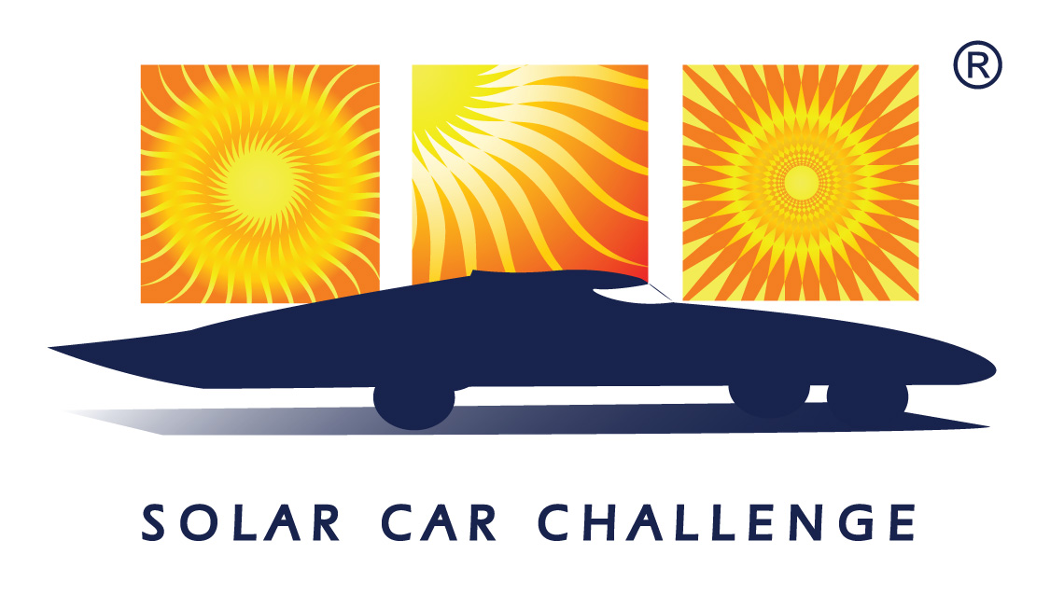

2021
Solar Car Challenge
Event Rules

Rev. –
Executive Summary

The Solar Car Challenge is an education program designed to motivate students in Science, Engineering, and Alternative Energy. The rules set out in this document form a portion of the guidelines for this project. Participants must also review the following additional documents to get a complete understanding of the program.

- Rules and Rules Updates
http://www.solarcarchallenge.org/challenge/rules.shtml
- Event Updates
http://www.solarcarchallenge.org/challenge/updates.shtml
- Registration/Scrutineering Forms
http://www.solarcarchallenge.org/challenge/forms.shtml

Significant Dates

Sept 1 – January 31 File “Intent-to-Race” Form
This notifies Event Officials of your team’s plan to participate in the Solar Car Challenge, and places your team on a mailing list to receive all event information

March 1st File Registration Document
This document includes:
(1) Official Registration Document
(2) Full documentation about your project as required in Section 3.6
(3) Registration Fee

Rules Structure

Sections 1-3 Purpose, Administration, Entries and Registrations

Section 4 Official Course

Section 5 Solar Car Regulations

Section 6 Nature of the Event

Section 7 Scrutineering [qualifying for the Solar Car Challenge]

Sections 8-10 Registration, Starting Order, Levels of Participation

Sections 11-22 Racing Guidelines

Sections 23-25 Judging, Penalties, and Protests

Section 26-30 Advertising, Media, Appropriate Teams Actions / Responsibilities

Section 31 Qualifying Events

Section 32 Electric-Solar Powered Car Division

Section 33 Cruiser Division

Index

- PURPOSE

The Solar Car Challenge is dedicated to the educational development of science and engineering students. On a broader scale, the challenge objectives are to stimulate interest in technical education, promote the use of renewable sources of energy, and raise public awareness of these issues.
- ADMINISTRATION
  - Application of Regulations – The regulations will apply to the Solar Car Challenge (SCC), hereinafter referred to as the “event.”
  - Effective Date of Regulations – The regulations become effective when issued in final form on September 1, 2020.
  - Right to Revise Regulations – The sponsor, as defined in Section 2.5 below, reserves the right to revise these regulations at any time by providing the participant written notice of the revisions in the form of Rules Updates on the web site.
  - Acceptance of Regulations – All persons or groups selected to participate in the event are assumed to know the regulations. Their participation in the event will constitute acceptance of all rules, updates, and guidelines promulgated by the event.
  - Sponsor – The primary sponsor of the event is The Solar Car Challenge, 3505 Cassidy, Plano, Texas 75023.
  - Selection of Event Officials – The sponsor will select event officials for this competition. These officials will be instructed in and be responsible for specific duties.
  - Authority of Officials – Solar Car Challenge Officials will have the authority and responsibility to apply these regulations.
- ENTRIES
  - Selection of Entries – Entries for the event are selected through a proposal system consisting of the evaluation of the application submitted by teams desiring to participate. The sponsor may select up to forty proposals total to participate in the event. The sponsor reserves the right to reject any proposal.
  - Teams and Drivers – Any number of people may act as the team, however, during the event, it is suggested that a manageable core team of approximately twelve members be designated as “the team.”
  - Team Provisions – During each event, special meal opportunities are provided to the teams in the form of an Opening Banquet and one meal per day. The event will provide each team with identification tags and meal tickets for up to 12 team members and 2 chaperones per team. Larger teams must make reimbursement arrangements with the sponsor prior to arriving at the event. A special water facility will be provided to the teams at the event start, required stops, impound, and qualifiers. All other water requirements must be supplied by the teams.
  - Makeup of Teams – Teams, including drivers, will consist of high school students in grades 9-12. Twelfth grade includes the summer following the student’s last year in high school. Team members must be from the same school district.
  - Qualifiers – Each team must successfully participate in a qualifier before they will be allowed to compete in the main event. Qualifiers will be held preceding the event. The qualifier will hereinafter be referred to as “scrutineering” and Stage One.

Teams can be pre-qualified to take part in the event by arranging for the Event Director, or one of his staff, to visit the team to determine if their solar car complies with the essential elements required to pass the scrutineering process. Teams will still have to proceed through the regular scrutineering process, but they are assured that their mechanical and electrical configurations comply with the basic event directives. Travel arrangements must be provided by the requesting team.
  - Reports and Data Sheets – Each team must submit reports and data sheets as follows:

Intent-to-Race Form – filed from September 1st through January 31st notifying Event

Officials of your team’s plan to participate in the Solar Car Challenge, and places your team on a mailing list to receive all event information. A Final Report will not be accepted for any team unless an Intent-to-Race form was submitted within the filing window.

Final Report – filed by March 1st of the year in which the team intends to participate.

This report must include:
(1) Official Registration Document
(2) Official Team Registration Fee [See Section 8.3]
(3) Final mechanical and drawings and electrical schematics (see below for details)
(4) Specifications including weight, dimensions, motor type, solar cell type, solar array power output, battery type and capacity, braking systems, wheel type, and data sheets as set out below. All crew members, designated drivers, and faculty advisors must also be listed.

The information from the data sheets will provide the basis for selection of event participants, and will appear in the Official Challenge Booklet. Teams will submit a digital and hard copy of the Final Report. The digital copy, including all documents below, must be in an Adobe PDF (.pdf) or Microsoft Word (.doc) format.
Six documents must accompany the Final Report:
- Mechanical Drawings: Complete, detailed drawing(s) showing the mechanical structure of the vehicle. This should be drawn with a drafting program such as Solid Edge for clarity and is not limited to one page. The drawing(s) must include crush zones, frame structure, and overall dimensions in three views (front, side, top). Dimensions should be labeled on each drawing. Crush zones must be explicitly labeled in the drawings and must include horizontal and vertical dimensions. Dimensions should also be shown for the height of the roll bar and between the driver’s head and the bottom of the roll bar. Drawings that fail to show adequate “360 degree crush zones” will be result in disqualification for the team.
- Electrical Schematics: A complete, detailed schematic and wiring diagram showing the electrical layout of the vehicle. This schematic must include but does not need to be limited to all the wiring for the propulsion, solar, instrument, and battery systems.
- A team photo in digital format of at least 1500x2100 pixels and in color. This photo may be submitted as a separate file from the report, but is due June 1st.
- Manufacturer’s data sheets for the propulsion system batteries, including, but not limited to voltage per battery, capacity per battery, weight of each battery, and its chemistry type (lead-acid, or otherwise). If batteries are not lead-acid, include manufacturer’s data sheets for an appropriate battery management system.
- Manufacturer’s data sheets for the solar cells you intend to use, including, but not limited to the size of each solar cell, the efficiency rating, the number of watts per cell, and the list price of each solar cell.
- Manufacturer’s data sheets for the motor, controller, main fuse, disconnect switches, wheels, and brakes you intend to use.
  - Changing Reports and Data Sheets – Teams will not be allowed to amend their Final Report once submitted without prior written approval by the Event Director.
  - Vehicle Design and Construction – It is the intent of the event that the solar cars be designed and constructed by high school students on the solar car team. The major components of the vehicle (frame, body, solar array, battery compartment, motor mount, drive system, electrical system, suspension, running gear, and lighting system) must be designed and constructed completely by the students. Off-the-shelf components (e.g., wheel hubs, brake calipers, power trackers, motors, motor controllers, suspension/steering components, wheels, etc.) may be used as long as the selection of these components was made exclusively by the students. No portion of another vehicle’s frame may be reused in a solar car unless the team re-engineers/modifies the frame to fit the team’s solar car design or to install separate off-the-shelf components. Teams can receive contributions of off-the-shelf components from other solar teams.
Teams can use body molds prepared by college or high school teams, but the actual vehicle body must be constructed by the students.
The students may seek the advice of engineers or other design consultants. Parts may be fabricated by specialty shops (for welding, machining, etc.) as long as the students specify what the specialty shop is to do, through drawings or specification sheets prepared by the students. However, it is the spirit of the event to learn how to build a solar car, and it is recommended that students perform whatever tasks they can to construct the solar car on their own. The drawings and specification sheets must be made available during scrutineering as proof of student design.
During Scrutineering, judges will strenuously question the students to determine compliance with this rule. Specific questions that will be asked during Scrutineering are set out in the Scrutineering Check Sheets found in the “Registration/Scrutineering” section on the web site.
  - Scrapbook – As evidence that solar cars are designed and constructed by high school students, teams must maintain a scrapbook showing students working on all phases of the solar car project, including planning, design, CAD, fundraising, building, and testing the solar car. Teams shall submit a digital copy of the scrapbook no later than June 1st. Teams shall also submit a hard copy of the scrapbook at the time of Oral Presentations. Scrapbooks will become the property of the Solar Car Challenge upon submittal.
  - Oral Presentation – Teams shall prepare an oral presentation describing their solar car project. The team will have up to 8 minutes to give a full statement about the team’s project. Teams will be graded based on whether the presentation gave a full statement about the team’s project and engineering decisions made, whether all team members participated, whether the presentation was well prepared and rehearsed, whether the team was able to speak without the use of notes, whether the team used visual aids, and whether the team’s scrapbook adequately showcases the team’s progress and development of the vehicle. Judges will question the team on their engineering decisions. Teams will be awarded up to 20 miles for the quality of their presentation and answers to judge questions upon qualification into the event. Penalties received during the event cannot affect awarded miles from the Oral Presentation.
- OFFICIAL COURSE
The Official Course on alternating years will be either the Texas Motor Speedway or a cross-country course announced on the Solar Car Challenge website http://www.solarcarchallenge.org.
- SOLAR CAR REGULATIONS
  - Physical Regulations
    - Dimensions – All solar cars entered will have the following maximum dimensions: length = 5 meters; height = 1.6 meters; width = 1.8 meters. Minimum height is 1 meter. When turning corners, wheels and wheel fastenings may exceed these dimensions. Fins, antennas, and other aesthetic components may not be used to meet the minimum height requirement. Antennas may extend above the maximum height requirement.
    - Stability – To ensure stability under various road conditions, the vehicle must employ either a three or four wheel design. If a three wheel design is used, event officials strongly suggest that the single wheel should be in the rear of the vehicle, with two wheels in front.

Regardless of the number of wheels chosen, it is recommended for vehicle stability that the ratio of the track (distance between the front wheels, measured at the center point of the tire footprint) to the wheel base (distance from front to rear wheels, measured at the center point of the tire footprint) be no less than 0.5 to 1.0. In other words, the track should be no less than one-half the wheel base. In addition, it is recommended that the vehicle track to total vehicle height be no less than 1:1.

During scrutineering, cars must demonstrate the stability of the vehicle. Either the front or rear wheel(s) or both may be powered, and either the front or rear wheel(s) may be used to steer the vehicle.
      - Suspension – Suspension components must be properly rated for the weight of the solar car. Improperly rated suspension components can lead to unstable handling and potential for roll-over. As such, suspension components must not exceed 50% of travel when fully loaded.
    - Body of the Vehicle – Although windshields are required, solar cars need not have a body or covering unless the event judges determine that the driving of that vehicle would be unsafe and/or create an unreasonable risk of harm to the driver. Solar cars are required to have a belly pan sufficient to protect the driver.
  - Structural Safety – Safety is the Sponsor’s primary concern with regard to the structural development and fabrication of the solar cars. Insufficient regard for structural safety will result in disqualification from the event during scrutineering.
In specific, solar cars must be constructed with three codependent structural safety components: a roll cage structure near the driver, a separate crush zone structure on the outside of the roll cage, and a roll bar. All structures must be designed to help protect the driver in the event of collision. The roll cage structure is intended to be constructed with heavier material so that it does not deform during the collision whereas the crush zone structure can be constructed with lighter material so that it gives way without deforming the roll cage and absorbs the energy of the impact.
    - Roll Cage – All solar cars must be equipped with a roll cage that provides rigid protection encompassing the entire driver in the event of a collision. The roll cage shall be a fixed, integral part of the solar car structure. The protection provided for the driver in a collision must be documented in the team's mechanical drawings. In addition to providing collision and rollover protection, the roll cage must be designed so as to deflect body/array panels of the car away from the driver in the event of an accident.
      - Minimum Dimensions – The roll cage tubing must have a minimum outside diameter of 1.9 cm. There must be at least 5 cm of clearance in all directions between the roll cage and the driver seated in the normal driving position. Teams must demonstrate at scrutineering that each driver complies with the 5 cm clearance.
      - Waivers – Teams wanting to use alternate dimensions must submit a waiver request to the Event Director before May 1. Waivers may not be requested at scrutineering. The waiver request must document what materials will be used and how these materials afford equivalent protection for the driver. A detailed mechanical drawing (in three views) must be included, showing the dimensions, material, and location of the roll cage members.
Waiver requests may be electronically submitted to the Event Director, so long as the request is saved in Microsoft Word or Adobe PDF format and the mechanical drawing is saved in a pdf.doc format. Waivers issued for previous years are invalid.
    - Crush Zone – A crush zone is defined as structural components that are designed to collapse in an effort to absorb some of the impact from a collision without impacting the driver space. The crush zone must provide driver protection from front, side, and rear collisions. As such, the crush zone structure shall completely encompass the driver’s head, upper, and lower body.
      - Minimal Horizontal Distance – There must be crush zone structural components at least 15 cm of horizontal distance away from the driver in every direction. Teams must demonstrate that all drivers comply with this regulation when seated in normal driving position.
      - Minimum Vertical Distance
(a) Front and Rear crush zone structures must, at minimum, encompass the driver’s head, upper, and lower body throughout the entire width of the driver’s compartment. Structural frame members shall cover the driver’s head, upper, and lower body when viewed from the front or rear of the solar car.
(b) Left side and right side crush zone structures must, at minimum, encompass the driver’s head, upper, and lower body and run from 15cm in front of the driver’s feet to 15cm behind the driver’s seat. Structural frame members shall cover the driver’s head, upper, and lower body when viewed from the left or right side of the solar car.
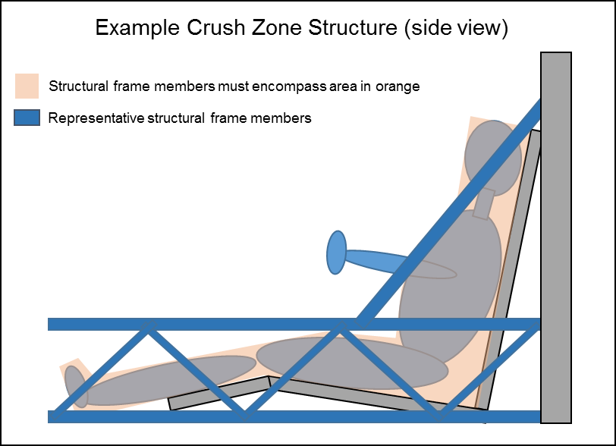
    - Roll Bar – The roll bar is the structural frame member that extends above the driver’s head, protecting the driver in the event of a roll-over. The roll bar must consist of one continuous piece of metal. The bottom of the roll bar must extend at least 5 cm vertically from the top of the driver’s head or helmet.

Solar cars where the driver’s head rises above the top of the solar car body must have additional roll bars to deflect the body component over the driver in the event of a collision.
      - Welded to Frame – The roll bar must be welded to the frame at no less than two points on each side of the driver to brace the bar from bending forward or backwards. The roll bar must be an integral part of the frame and cannot be removed.
      - Minimum Dimensions – The roll bar tubing must have a minimum outside diameter of 5 cm. It must also have a minimum wall thickness of 1.0 mm for chromoly steel, 1.5 mm for carbon steel, and 3.2 mm for aluminum.
      - Waivers – Teams wanting to use alternate materials, dimensions, or attachment method must submit a waiver request to the Event Director before May 1. Waivers may not be requested at scrutineering. The waiver request must document what alternate materials will be used and how these materials afford equivalent protection for the driver. A detailed mechanical drawing (in three views) must be included, showing the dimensions, material, and location of the roll bar.
Waiver requests may be electronically submitted to the Event Director so long as the request and mechanical drawing are saved in Microsoft Word or Adobe PDF format. Waivers issued for previous years are invalid.
    - Composite Material – The use of composite materials is permitted on the solar car. However, if composite materials are used in the roll cage, roll bar, or crush zone, the team must send a sample of the materials to a professional organization specializing in destructive testing to verify adequate structural strength and submit the resulting report to Event Officials for evaluation.
  - Solar Array – Global solar radiation received by the car directly from the sun is the only power source that will be stored or used for propulsion.
    - Solar Cell and Array Size Limitations – Solar cell types are restricted by division and set out in Section 10. For all vehicles, the solar array may be configured in any way, provided that the size of the array fits within the maximum dimensions of the solar car.
When stationary, the solar array may have any orientation to the sun. The solar array must remain mounted on the outside of the vehicle, except as provided in Section 5.3.4. The solar array cannot be dismantled and carried inside the vehicle.
    - Array Configuration – The solar array cannot be reconfigured, without specific written permission of the Event Director. Reconfiguration is defined as changing the position or orientation of any portion of the array. Changing the position or orientation of the entire array, when stationary, is not considered reconfiguration. When stationary, the array may exceed the maximum height of the solar car so long as the array is not reconfigured.
    - Reflector – No reflector-type device can be used to enhance the collection capacity of the panel.
    - Umbilical Cord – To position a solar car’s solar array in a favorable position for charging, an umbilical cord may be used. This cord must be carried on the solar car.
The purpose of the umbilical cord is to provide the racing participant the means to keep the array electrically connected to the vehicle, though physically removed from the vehicle to receive more favorable sunlight. Teams reconfiguring only a portion of the array must request explicit permission for reconfiguration, as required in Section 5.3.2.
  - Battery – In the interest of cost and standardization, only rechargeable, commercial production, lead-acid batteries are permitted (unless otherwise allowed in Section 10). The total battery capacity cannot exceed 5 kilowatt-hours at a 20 hour discharge rate. There is no limit applied to system voltage, number of cells, or modules. Capacitors can not be used to supplement the 5kwh battery capacity. Batteries may not be “supercharged” to exceed the 5 kWh limit. “Supercharged” is defined as exceeding 16% of the nominal battery voltage (e.g. charging 12 volt nominal batteries to voltages over 14 volts). Manufacturer documentation must be provided for all battery types.
    - Main/Propulsion Battery System – Solar cars must be equipped with main/propulsion batteries to power the solar car. The main/propulsion battery system must be completely isolated from the supplemental system of the solar car. The main/propulsion battery pack may not be used to power anything other than propulsion devices.
      - No Battery Reconfiguration – Once the event has begun, the batteries in the main/propulsion battery box cannot be reconfigured without specific written permission of the Event Director. Reconfigured is defined as changing the connectivity of the individual batteries in the main/propulsion battery system.
    - Main Battery Pack Fuse – The main battery pack fuse must be placed first in series off the positive or negative terminal of the main/propulsion battery system. (See subsequent diagrams for details.)

(a) When the battery pack fuse has been blown, the positive or negative side of the Main Battery Pack must be completely isolated.

(b) Main Battery Pack Fuse must be rated for the appropriate DC voltage. AC voltage ratings shall not be used to determine proper rating.

(c) Main Battery Pack fuse must be rated for no more than 125% of the expected peak current draw.

(d) Main Battery Pack fuse must be placed in an enclosure (hereafter “HV enclosure”) separate from any battery enclosures or power tracker enclosures that will completely contain the fuse in the event of an aggressive failure of the fuse. The HV enclosure must be no more than 15cm from the outside of the Main/Propulsion Battery box where the lead exits the battery box.

(e) Manufacturer documentation must be provided for the Main Battery Pack fuse.

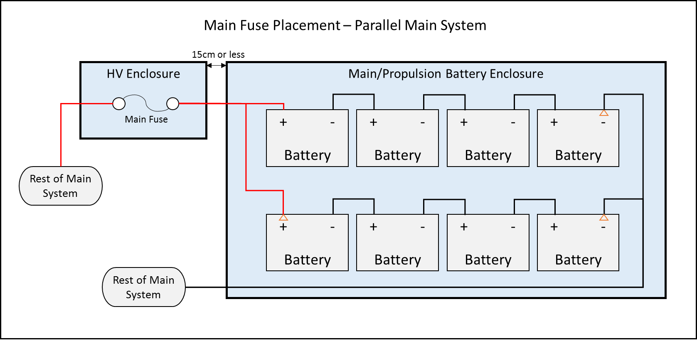

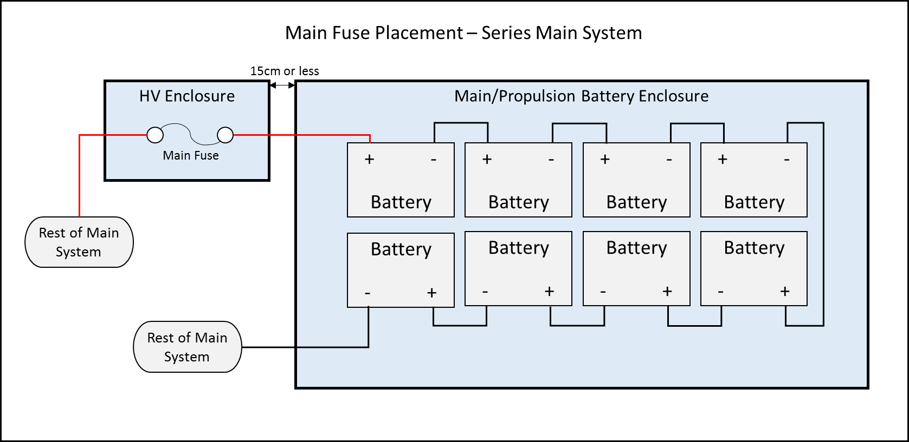
    - Battery Enclosure - The main battery pack must be fully contained in enclosures that can be sealed by event officials (thus sealing the batteries). A hasp latch for the battery enclosure will assist event officials in complying with this section of the rules.
- A battery enclosure is defined as a rigid box-like structure constructed from materials that are not easily flexible and that provides protection and stability to the battery system in the event of collision. Battery bags are not allowed.
- Batteries need to be strapped down, or held in place using structural members so that they will not move in the event of a vehicle roll over. If conductive materials are used to fasten batteries inside of the battery enclosure they must be properly insulated.
(c) The inside surfaces of battery enclosures made from conductive materials must be completely insulated.
(d) Battery boxes may not be used as dedicated crush zones as defined in Section 5.2.2. As such, battery boxes must not be located at the front of the vehicle frame.
(e) Other than forced air ventilation system intake and exhaust, the battery box must be air tight. Neither the intake nor exhaust may be open to the driver’s compartment.
(f) Battery boxes for lead-acid batteries must have forced-air ventilation which must operate whenever the battery system is electrically connected to the solar car, that maintains negative air-pressure within the box, cycles the air in the box 4 times per minute, and vents to the outside of the vehicle behind the driver’s compartment. [See diagram below]
There must be at least 3 cm of clearance between any devices inside the battery enclosure and both the intake and exhaust of the battery enclosure to ensure necessary room for air flow. Neither the intake or exhaust may be open to the driver’s compartment; ducting the exhaust behind the driver’s compartment is acceptable.
(g) Each battery and the battery box must be securely fastened to the vehicle’s structure so that the box will not move in the event of a crash. Nylon straps can be used to help secure the battery box; Velcro does not meet this requirement.
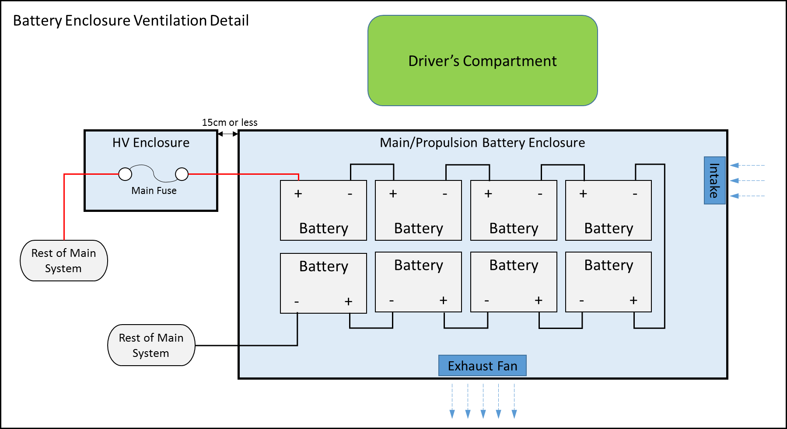
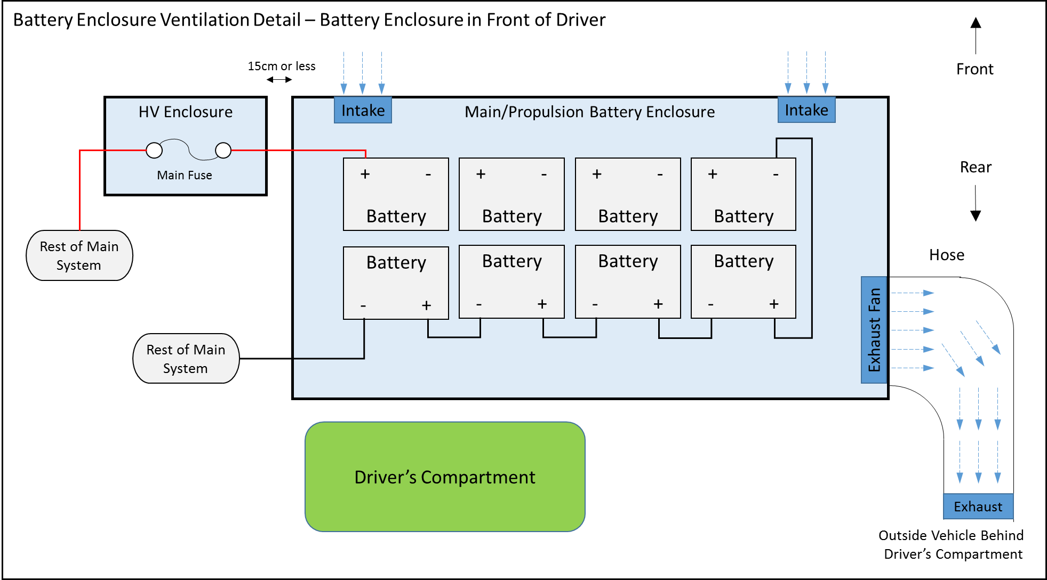
    - Supplemental Batteries – All solar cars must be equipped with supplemental batteries to power solar car accessories requiring an external power source, such as, but not limited to, electronic speedometers, cameras, memory devices, telemetry transmission, and battery box fans, and they must be totally isolated from the propulsion system of the solar car. Telemetry systems may have a common ground with the propulsion system, as long as the current draw is low. The main battery pack may not be used to power anything other than propulsion devices.

- Battery Type – There are no regulations limiting the type, voltage, or weight of supplemental batteries.

- Low Battery Warning System – The supplemental batteries powering the following equipment: (1) lights; (2) horn; and (3) battery box air circulation fans, must be equipped with a low voltage warning system that will aggressively warn the driver with an audible alarm when the supplemental battery pack is getting low.

- Proper Mounting – Supplemental batteries must be securely fastened to the vehicle’s structure so that the batteries will not move in the event of a crash or vehicle roll over. Nylon straps can be used to help secure the batteries; Velcro does not meet this requirement.
    - Disconnect Switches – Solar cars must have “kill” switches wired to disconnect all power to the motor and solar array. A total of four disconnect switches are required – two each to interrupt current to the motor and array. One set of motor and array disconnects shall be accessible by the driver, within arm’s reach, and another set shall be accessible by bystanders external to the vehicle. Each disconnect must be capable of carrying and interrupting the full load current at system voltage. For 2021, disconnects may either be directly operated (switch interrupts full load current) or operate a relay/contactor. The relay/contactor must be located within the HV enclosure, as described in Section 5.4.2. Teams are strongly encouraged to use a relay/contactor in 2021 to isolate high voltage conductors from the driver compartment. Starting in 2022, solar cars must be equipped with disconnect switches that operate a relay/contactor to interrupt the full load current. Relays/contactors must be continuous duty, normally open, and capable of carrying and interrupting the full load current at system voltage.

- Disconnect switches must be push-pull, where the circuit is broken when the disconnect switch is pushed in.

- Disconnect Switches must be clearly labeled in 10mm-high letters, and be plainly marked with “ON” and “OFF” positions. Motor disconnect switches shall be labeled “Motor Disconnect” and array disconnect switches shall be labeled “Array Disconnect” Switches shall be labeled with the directions for operating the switch, such as “Push for Off.”

- Manufacturer documentation must be provided for all disconnect switches and relays/contactors and show that the devices being utilized are rated properly.

- Disconnect switches must be securely fastened to the vehicle structure to prevent failure in emergency situations.

- Disconnect switches must be in plain sight by a bystander in standing position and may not be hidden under panels.

- Disconnect switches (or relays/contactors if used) must be in series with no other devices or connections between them. The motor disconnect shall be placed first in series on the positive connection to the motor controller. The array disconnect shall be placed first in series on the positive connection to the solar panels or solar array power trackers, if used.

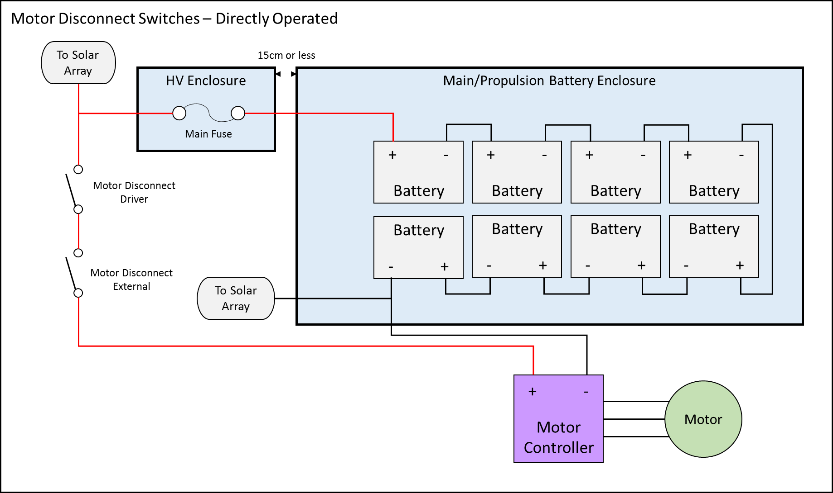
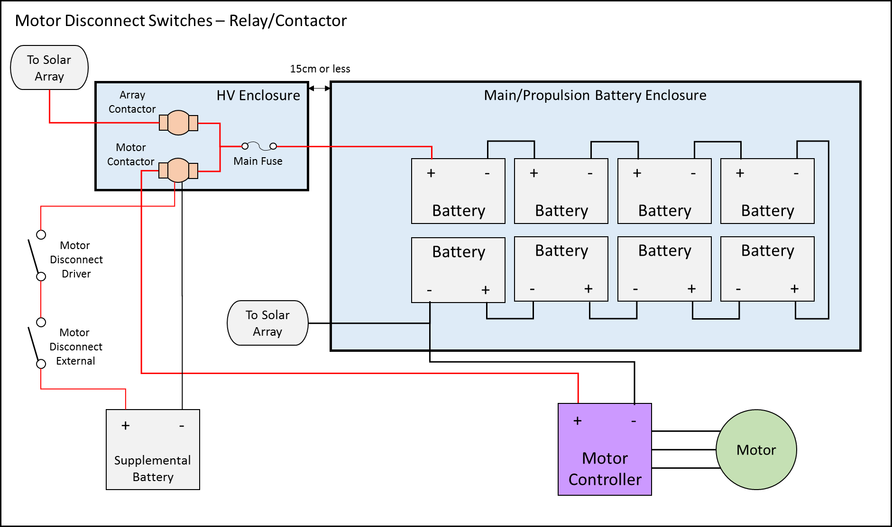

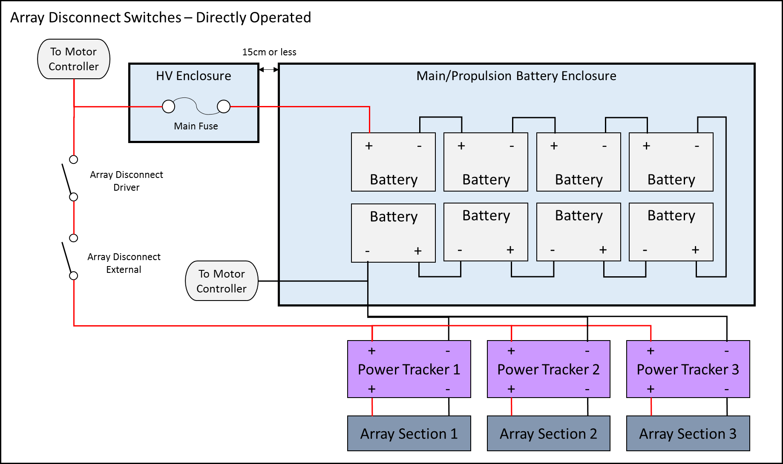

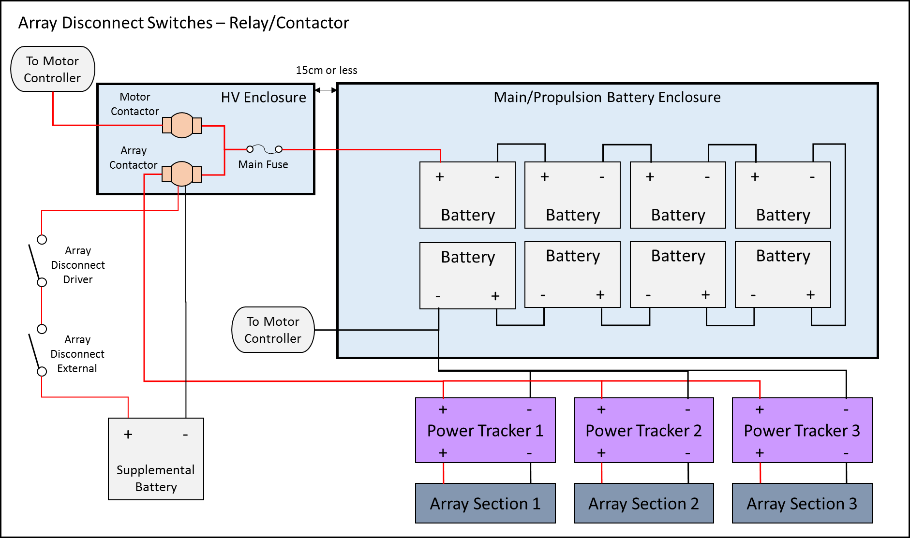

  - Electrical System Grounding – Neither the main/propulsion system nor the supplemental system may be grounded to the vehicle’s frame. Electrical system grounding shall mean that a resistance of less than 1 MΩ between electrical components and the vehicle’s frame when voltage is applied.
  - Assistance Devices – Any device used to assist the start, stop, or powering of a solar car must be carried on the solar car and must be a permanent part of the electrical system. Once the event has started, teams will not be allowed to plug any devices into the solar car except telemetry equipment and multimeters.
  - Wire, Insulation, and Connections
    - Wire – All wires must be properly rated for voltage and temperature. Wires must be properly sized to expected continuous system current. Wires must be properly and neatly secured to prevent movement or snags during solar car operation. Wires must be secured by a protective grommet when passing through a bulkhead. Starting in 2021, no wire conducting more than 36 volts may be located within the driver’s compartment.
    - Insulation – All electrical connections must be insulated using techniques that will withstand the temperatures and vibrations they are exposed to while operating a solar vehicle. Heat shrink and battery caps are the preferred method for insulation. Electrical tape shall not be used to insulate any propulsion system wires.
    - Connections – All electrical connectors must be rated for voltage, amperage, and temperature. Connections must be able to handle the vibrations they will encounter during when driving a solar car on the road. All connections conducting more than 36 volts must be properly secured with locking washers. Wing nuts and wire nuts of any type are not acceptable connecting techniques on a solar vehicle.
  - Seating Position – Each occupant must be provided with an appropriately constructed seat where the occupant’s head is higher than his or her feet. [See Section 5.13(j)]
  - Visibility – In the normal driving position, each driver's eyes must be a minimum of 70cm above the ground. All visibility rules must be met with the driver securely fastened into their harness in a normal driving position.

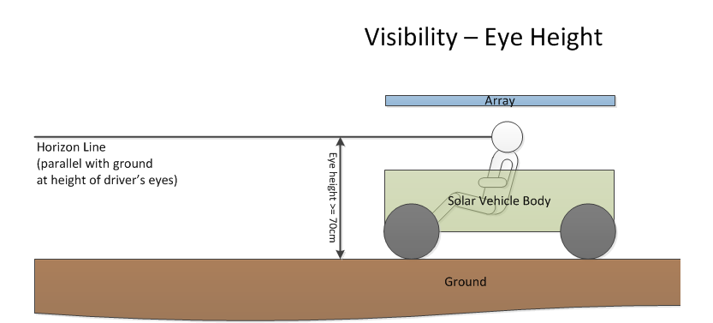
    - Forward Visibility - From the normal driving position, all drivers must be able to see, without artificial assistance: (1) a point on the ground 8 meters in front of the solar car.
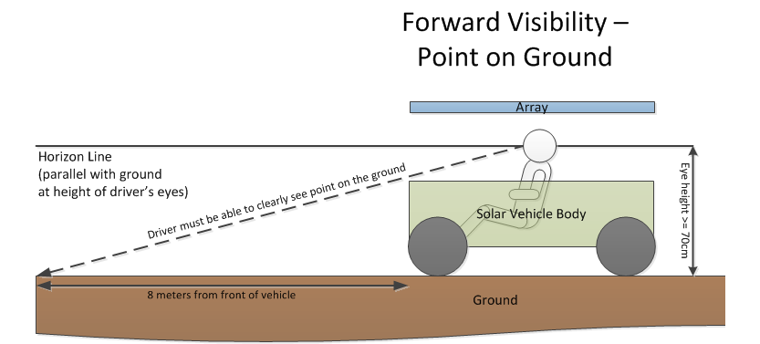
Forward Visibility – (2) A minimum of 10 degrees above the horizon on level ground.

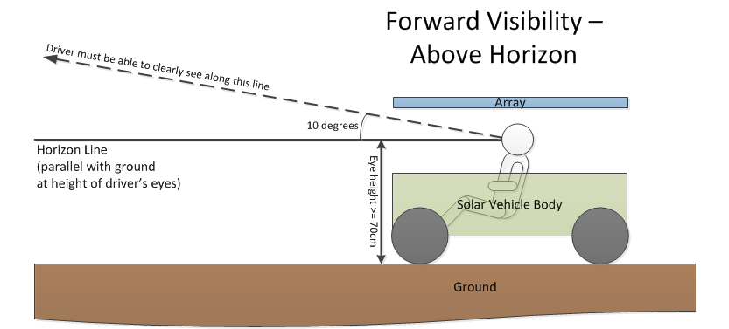

    - Side Visibility – From the normal driving position, all drivers must be able to see, without artificial assistance, 90 degrees to either side at all times. This must be essentially unobstructed by the solar car structure. The intent is for the driver to see oncoming traffic, left and right.

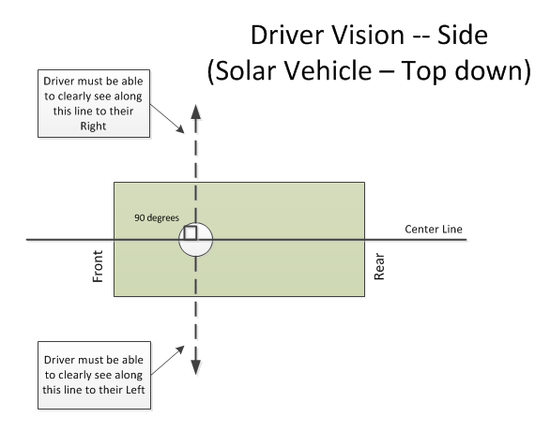

    - Rear Visibility – All solar cars must be equipped with a rear vision system that will allow the driver to see a vehicle 15 meters directly behind the solar car, as well as see vehicles 45 degrees in each direction approaching from the rear. If an electronic rear vision system is used, it must operate whenever a driver is present in the vehicle.

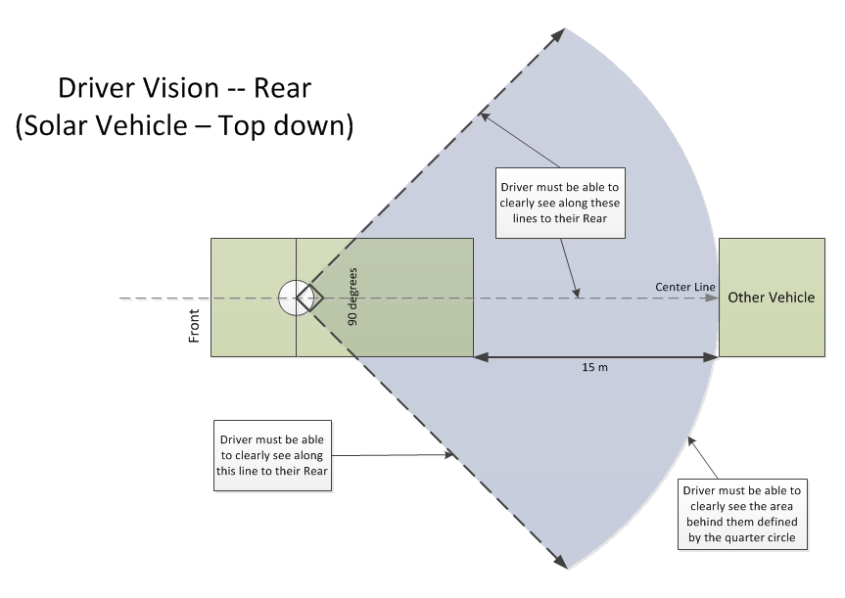

  - Braking – The intent of the Sponsor is to require that solar cars be capable of braking and coming to a safe stop based upon road and traffic conditions. To this end, solar cars will be equipped with two separate, independent braking systems. This means that there must be two separate foot pedals (one for each braking system) and that each is connected to a different actuating device. The two separate foot pedals may be linked together, so long as the pedal assembly engineering is sound and each foot pedal can be independently operated if the linkage fails. Each braking system must apply brakes to the left and right sides of the solar car evenly. Regenerative brakes are not considered a braking system for consideration in this rule.
During scrutineering, solar cars will be required to demonstrate their braking capability at both 20 mph and at the vehicle’s maximum speed.

Low Speed – At 20 mph, the driver must be able to bring the vehicle to a safe, controlled stop in no
more than 2.5 seconds.

High Speed – At the vehicle’s maximum speed, the driver must be able to bring the vehicle to safe, controlled stop without drifting out of the appropriate lane of travel, and within a reasonable time frame based on that vehicle’s maximum speed.
  - Steering – All steering must be directly operated by the driver with a steering wheel that is round and has a continuous perimeter. All components between the driver's steering wheel and wheel turning mechanisms must be connected via direct mechanical linkages. No electrical actuators or controls are allowed.
    - Turning Radius – Solar car wheels must be able to make a U-turn in a 15-meter wide lane in each direction.
  - Warning Systems
    - Lighting – Solar cars must have stoplights, front and rear turn indicators, and hazard lights. The geometric visibility of each light should be 45 degrees from center and 15 degrees up and down.

(a) Stop lights must be red in color. Turn indicators and hazard lights must be amber in color.

(b) Stop lights must be visible at 100 meters and mounted to maximize rear visibility. All other lights (front/rear turn indicators and hazard lights) must be visible from 30 meters away.

(c) Stop lights must be pedal activated by both primary and secondary braking systems.

(d) At the event official’s discretion, teams may receive a “moving violation” for each incidence of non-working lights. Once the team is notified by an event official that they have a non-working light, they must safely remove themselves from the official course and make the necessary repairs.

(e) On cross-country races, both chase vehicles must be equipped with four amber ECCO 3510 or 3518 warning lights.
    - Audible Warning – Drivers must be able to give audible warning to pedestrians and other vehicles using a horn producing at least 92 decibels as measured at the source. The horn shall be mounted as far to the front of the vehicle as possible and face forwards. The horn may not be located inside the passenger compartment. Air horns may not be used as a horn device.
In closed-track events, the horn must be sounded when a solar car attempts to overtake and pass another vehicle. .
  - Driver Safety – Teams must take whatever steps necessary to protect the safety and well-being of the drivers. Driver safety measures include, but are not limited to:

- Safety Belts – Solar cars must be equipped with a minimum of a five-point lap and shoulder belt (harness system). The use of safety belts is mandatory at any time the vehicle is moving. The belts must be attached securely to a structural component or main frame member of the solar car, per manufacturer’s instructions. The harness must be attached with bolts at least grade 8 and 3/8” in diameter. No belt shall be punctured in order to mount it to the solar car.

- Impact Protection – The driver compartment must be equipped with structural components that help protect the driver from vehicle roll-over, or from front or side impacts, in compliance with Section 5.2 (above). All sharp objects and frame members within the driver area must be padded to help protect the driver during entry and egress and in case of impact.

Teams with body shells are required to have the shells securely attached to each other to reduce the threat of injury in the event of a collision.

- Protection from Vehicle Components – All equipment housed within the vehicle must be adequately secured to the main frame to prevent the shifting of that equipment during an impact. Special emphasis is placed on securing the batteries due to their weight and potential for environmental damage.

- Windshield – All solar cars will utilize windshields at all times to protect the driver from road hazards. Windshields must provide protection for the entire head of the driver.

- Cockpit Egress – Each driver must be able to demonstrate that unassisted egress can be achieved in less than 15 seconds in the event of an emergency. The “exit process” will be carefully checked by event officials during scrutineering. Other team members cannot assist the driver during this required “exit process.”

- Fire Extinguishers – Cockpits must be equipped with a Class C fire extinguisher which can be easily reached by the driver in the event of an emergency. Chase vehicles must also be equipped with either a Class C fire extinguisher (for lead-acid batteries), a Class D fire extinguisher (for Lithium-metal batteries), or an appropriate fire extinguisher for other battery chemistries.

- Liquid Container – Cockpits must be equipped with a plastic liquid container filled with water, which can be easily reached by the driver. The liquid container must be secured from movement such that it cannot roll underneath the brake and throttle controls.

- Belly Pan – The cockpit must be equipped with a full belly pan to isolate the driver from the road. The belly pan consists of a solid material resistant to puncture throughout the driver compartment.

- Air Circulation – Forced air ventilation must be provided for the solar car’s driver. This is particularly important for the health and safety of the driver while the vehicle is powered but not in motion. This requirement applies whether or not the driver’s compartment is enclosed or open.

- Driver Seat – When the driver is seated in the normal driving position, the driver’s seat must provide back and neck support for the driver, such that whiplash will be minimized in case of an accident or sudden stop. The seat must be rigid and attached to main structural frame using at least grade eight bolts 3/8” in diameter.

- Battery Spill Kit – A battery spill kit consists of a box of baking soda, to mitigate the effects of battery spills. All teams must carry a battery spill kit in the solar car, within reach of the driver. All teams must also carry a second battery spill kit in their chase vehicle.
  - Throttle – Accelerator mechanisms on solar cars must be free moving and when released, must return to the zero current position. If the solar car is equipped with cruise control, it must be designed with an automatic shut-off when the brake is activated. Solar cars may only be equipped with a cruise control system during closed-track events. All accelerator mechanisms (manual throttle or cruise control) must be directly operated by the driver. At least one accelerator mechanism must be foot-operated.
  - Covers and Shields – The solar car’s revolving parts, such as, but not limited to chains and belts, must be suitably covered to prevent accidental contact by the driver. All steering linkage must be shielded from the contact of the driver. If a flywheel is used, it must be covered by a National Hot Rod Association-approved shield.
  - Electrical Shock Hazards – All conductors must be properly insulated. All conductors operating at greater than 36 volts must be marked with “High Voltage” warning signs. All solar cells and panels must be marked with “High Voltage” warning signs. All leads extending from the solar array must be properly protected to eliminate accidental shock hazards resulting from participants or bystanders coming in contact with these leads.
Event Officials strongly suggest the following steps to improve safety:
- When working with the battery box, be sure that you only use one hand, and that the other hand is kept behind your back. In the event of an electrical shock, the charge will not pass through the entire body.
- When working with the battery box, be sure to use rubberized tools to insulate against the possibility of electrical shocks.
- Students working in the battery box require continuous supervision by teachers or chaperones.
- When working with the battery box, be sure to wear eye protection (a full face shield is best) to protect against battery explosions caused by sparks or arcing.
  - Radios – Solar cars must be equipped with a two-way radio to allow communication with the chase vehicle. Teams must demonstrate during scrutineering that the transmission from the solar car can be received at a distance of at least 0.5 miles. If a radio system “goes down” during the event, drivers must stop at the earliest opportunity and make repairs before proceeding on the course.
Judges will make every effort to ensure that a team’s radio communications will remain private, unless there is a safety issue involved.
  - Fasteners – All fasteners associated with the vehicle’s suspension, steering, brakes, seat belts, and drive train must be equipped with locking nuts, double nuts, or nuts secured with safety wire or cotter pins. Loctite may be used in areas of difficult accessibility. When nylon locking nuts are used, the bolt must extend past the nut by at least one thread.
  - Graphics
    - Inappropriate Graphics – The event organizer reserves the right to disapprove any graphic it deems offensive.
    - Sponsored Graphics – Teams must reserve a space 10" (horizontal) by 10" (vertical) on both sides of the vehicle for official event graphics. The sponsor graphics location should be near the front of the solar car.
  - Tires – All tires must be loaded and inflated per manufacturer’s guidelines. No tire may be inflated at pressures higher than what is written on the tire’s sidewall or manufacturer’s data sheets.
- NATURE OF THE EVENT
Closed-Track Event
In alternating years, the event will consist of either a multi-day closed-track event or a cross-country event. During a closed-track event, teams will cover the same course each day with the same specific start and finish line at the Texas Motor Speedway. Teams will accumulate full laps around the Texas Motor Speedway (no partial laps will be awarded). The team that completes the most laps during the event will be declared the winner. The team that completes the same number of laps with a lower elapsed time than another team will place higher than the other team. The details of closed-track events will be spelled out in Rules Updates for that specific year’s event.
Cross-Country Event
For a cross-country event, teams will drive or trailer their solar car on a specified route over the course of several days. The team driving the most miles in their solar car over the course of the event will be declared the winner. The team completing the same number of miles with a shorter elapsed time will place higher than the other team. A tie shall be declared for teams completing the same number of miles and a difference in elapsed time of less than 1%. This allows for judging tolerance for recording time. The details of cross-country events will be spelled out in Rules Updates for that specific year’s event.
  - Elapsed Time – On each day of the event, a team’s elapsed time begins at its allotted time slot (based on starting order). A team’s elapsed time ends when it completes the course for the day, or when time has elapsed for the day, whichever is earlier. Time spent at required stops or when teams are required to trailer a particular course segment are deducted from the elapsed time.
  - Challenge Events – Teams will be required to take part in all events and activities, including the opening banquet, closing banquet, and all scheduled pre-challenge and post-challenge events. Teams will be notified of all events at Team Check-In. In addition to pre-challenge and post-challenge events, teams must participate in one event throughout the year to support the Solar Car Challenge. A list of such events will be provided at the beginning of each race year. Teams failing to participate in all events and activities may be disqualified from the event.
  - Items Provided by the Solar Car Challenge
- Comprehensive Challenge Booklet
- Guide to Hotel/Motel/Campsite Accommodations
- Emergency Medical Personnel
- Judges Accompanying Each Team
- On-road police protection (where appropriate)
- One meal per day from the Opening Banquet
(For up to 12 team members and 2 Advisors)
- Special Texas License Plate (for cross-country events only)
- Caution: Solar Car Ahead Signs (for cross-country events only)
- Drinking Water
(At Scrutineering, Start & Finish Lines, Media Stops, and Vehicle Impound)
- Security for Solar Cars during nightly impounds
  - Items Provided by Entrants – All items not specifically enumerated in Section 6.3 (above) will be provided by entrants, unless set out in Rules Updates. Teams must remember to provide driver’s licenses for designated Team Drivers, as well as Proof of Vehicle Liability Insurance.
  - Trailering Provisions – Teams may trailer their solar cars at any point on the cross-country course (unless otherwise restricted by the Where-to-Be, What-to-Do document). Teams will not accumulate any miles spent trailering their solar car. Teams must trailer their solar cars when required to do so in the Official Route booklet.
  - Time - Central Daylight Time is the “official” time for all events. When a cross-country route moves into another time zone, the time within the zone when the day started will be considered the “official time” for all events conducted in that new time zone on that day.
  - Driving – For cross-country events each team will be released from an official Starting Line at fixed intervals and all racing will stop at a fixed interval after the team’s allotted time slot. The detailed schedule for each day will be published on the Solar Car Challenge web site and on the Where-to-Be, What-to-Do document. For closed track events, the racing schedule will be published on the Solar Car Challenge web site.
When driving on the cross-country course, teams must maintain a minimum speed of 15 mph. If the solar car is unable to maintain that speed, it must safely pull off the road and charge their batteries.
When road shoulders are available, teams should periodically pull over to allow traffic to pass.
  - Charging – Teams may charge their solar car batteries during daylight hours up to the time for impounding the vehicles. Charging of the main battery pack must be done in the presence of an event official, and can only be charged by direct solar radiation.
  - Impound – All solar cars will be impounded under event security each day. Teams may start removing their solar cars from the Impound when opened by event officials. Once the event has begun, no team will be allowed to remove their vehicle from the Impound without the escort of an event official. The car must remain under the direct supervision of an event official throughout the day until it is again submitted for impound. Teams violating this rule may be disqualified from the event. Specific impound times can be found on the Where-to-Be, What-to-Do document.
  - Equipment Safety – Teams may and should bring equipment to maintain and/or repair their solar car to the event. Such equipment shall be stored in a safe manner and in compliance with appropriate safety regulations (e.g. OSHA) when applicable, such that members and surrounding teams will not be harmed. For example, welding gasses shall be stored vertically and strapped down so it does not inadvertently tip over. Any equipment with wheels or casters should be secured or tilted such that it does not cause someone to slip.
  - Attire – Attire for all participants (including students, sponsors, chaperones, advisors, and others participating or traveling with team) in the Solar Car Challenge must be appropriate. All participants must wear full-brimmed hats when in direct sunlight and closed-toe shoes throughout the event. Jeans are recommended for protection when working on the car and when kneeling on the ground. Shorts must be longer than the longest fingertip.
- SCRUTINEERING
  - Scrutineering Time – Solar cars will be inspected to verify compliance with the regulations at 8:00 AM on the day preceding the event (subject to change). Vehicles not ready to begin scrutineering at this time will be penalized up to 5 miles.
  - Inspected Solar Cars – Solar Cars that pass scrutineering will be allowed to participate in the event. Vehicles that do not pass scrutineering must correct the deficiency in order to be considered for participation in the event. After repairs are made, the team has the responsibility to notify event officials that their vehicle is again ready for scrutineering. Vehicles will continue to be inspected according to the schedule set out in the Where-to-Be What-to-Do document. Vehicles may be subject to inspection at any time.
    - Elimination – Teams failing to complete all scrutineering stations within the allotted scrutineering time will be eliminated from the race, upon direct consultation with the Event Director. No team shall be eliminated without such consultation.
  - Safety – Each team is responsible for the road-worthiness of its solar car. Passing the scrutineering process does not relieve the team of its responsibility, nor impose any liability on the event organizers. Solar cars must be maintained in a safe, road-worthy condition at all times.
  - Liability – Teams will be required to sign a Release of Liability Form prior to admission to the event. Proof of Vehicle Liability Insurance will also be required at the time of Team Check-In. On cross-country event years, teams must submit their Proof of Vehicle Liability Insurance no later than June 1st.
  - Braking – Solar cars will be required to meet the braking guidelines set out in Section 5.10. Failure to meet these guidelines will require the team to make the necessary changes to bring their vehicle into compliance, and then to be re-tested. Any solar car that does not pass the brake test will not be allowed to enter the event.
Teams whose cars are equipped with cruise control systems, as allowed by Section 5.14, will be required to explain how the cruise control system is disengaged when brakes are applied, and to demonstrate its function.
  - Handling – Solar cars will be required to run through a slalom course, weaving in-between at least six cones spaced approximately 40 feet apart, to ensure proper handling when lateral forces are exerted on the frame and wheel assemblies. Each driver must pass the slalom course to quality to drive in the event. Drivers receive their official “driver’s wrist band” after completing the slalom.
  - Safety Meeting – Team drivers and advisors will be required to attend a safety meeting scheduled after Team Check-in.
  - Safety Equipment – Each team must demonstrate during scrutineering that it is prepared to handle emergencies. This includes the designation of a team safety coordinator. The following equipment must be easily accessible to the team: fire extinguishers (both on the solar car and the chase vehicles), traffic cones or warning triangles, orange warning flags, safety vests (for driver, safety officer, and team members entering the track or on the road), and jack stands. Jack stands must be used whenever the solar car is off the ground for maintenance.

Teams working on their solar cars in the garage area are required to use protective eyewear. A penalty will be assessed for failure to wear protective eyewear.

When welding, teams must use a welding curtain to shield from visual damage. Teams must also provide protection for damage to the floor.
  - Safety Holds – Event Officials reserve the right to hold any solar car from proceeding on the race course at any time if they feel the car has potential safety issues. Examples of safety issues include unsafe handling, risk of rollover, and unsafe driving behavior. Teams must rectify the safety issue to the satisfaction of the Race Technical Director or Event Director before being allowed to proceed on the race course.
  - Post-Event Inspection – At the conclusion of the event, the event officials may conduct a post-event inspection of the first place team in each division. In addition, event officials will have the discretion to conduct post-event inspections for all other teams. The post-event inspection will confirm that the car complies with event regulations and that the components in the car agree with the Data Sheets [See Section 3.6] submitted to the event. If a car fails any portion of the post-event inspection, the team will be penalized based on the provisions set out in Section 24.
- REGISTRATION
  - Purpose – The purpose of registration is to identify participants and vehicles taking part in the event.
  - Registration Deadlines – Teams must file an Official Registration Document no later than March 1st of the year the team plans to participate. See Section 3.6 for additional details on registration documents.
  - Fees – Registration for the Solar Car Challenge must be accompanied by a non-refundable $1,500 fee (for closed-track events) or $2,000 fee (for cross-country events) on March 1st of the year the team plans to participate. Registration fees are non-refundable and may not be credited to a future event
  - License Plates – No license plates are required on the closed-track events. The SCC will supply a 30-day special Texas License Plate for cross-country events to teams providing proof of solar vehicle liability insurance. [See Section 7.4]
  - Participants Registered – Any person taking part in the event must be registered, and must wear an official SCC Identification Badge around their neck at all times. This includes media, sponsors, officials, guests, and teams. The Identification Badge must be visible at all times. All participants must be present at Team Check-In. Media seeking to cover the race must receive specific written permission from the Event Director prior to the official race start.

Team guests are required to follow the same safety guidelines as the team. This includes, but is not limited to the hat and closed-toe shoe requirement.
  - Driver Restrictions – Solar car team drivers must have a valid driver’s license. All drivers will be specifically identified at registration. Only registered drivers will be allowed to drive during the event. On each day of the event, solar car drivers must report the name (and function) of any drug that they are using. The report should be made to the Event Director prior to the drivers' meeting.
  - Driver Weight – No ballast provisions are required in the Classic, Open, or Advanced Divisions. A ballast requirement is set out in the Electric-Solar Powered Car Division. [Section 32]
  - Liability Insurance – Teams must submit proof of liability insurance on their solar car during the scrutineering process. On cross-country events, teams must submit proof of liability insurance no later than June 1st of the year in which they intend to participate. Teams not complying with this rule will receive an automatic penalty during Scrutineering, and may be disqualified.
- STARTING ORDER
  - Starting Order - The starting order for the first official day will be determined by a drawing at Team Check-In. On all other days, the starting order will be determined by the solar cars’ previous day mileage.
  - Release from Starting Line - The solar cars will be released from an official Starting Line at fixed intervals. If a solar car is not ready for its assigned starting slot, it will be detained until all remaining cars have been released. Time will start for the detained car at its assigned starting slot, not when the detained car is released.
- LEVELS OF PARTICIPATION
  - Event participants must choose to participate in one of the following five divisions of racing. Event Officials reserve the right to recategorize teams into a different division if there are less than 3 teams in any one division.
    - CLASSIC DIVISION – The Classic Division retains all the rules and regulations set out in the Official Rules. No hub motors can be used. Solar modules must be have a rated efficiency of 20% or below. Prefabricated solar panels are rated per module efficiency. Bare solar cells are rated per cell.
    - ADVANCED CLASSIC DIVISION – Schools desiring to enter in the Classic Division, but have participated for three or more years in the Solar Car Challenge must be entered in the Advanced Classic Division. This division retains all the rules and regulations of the Classic Division.
    - ADVANCED DIVISION – The Advanced Division provides teams an opportunity to explore new and upcoming technology for their solar car. In addition to rules and regulations set out in the Official Rules, teams may use a hub motor, solar cells that have a rated efficiency above 19%, prefabricated solar car molds and/or other battery types.

The list price for all bare solar cells must be less than $10/watt; teams may pay extra for cutting, tabbing, or lamination of cells.

Prefabricated solar car molds are defined as molds designed for solar cars that are not directly constructed by team members (i.e. molds purchased, donated, or otherwise obtained). The body made from these molds must be made by the team.
Batteries may be of any chemistry type, but must have the appropriate protection systems required by that type. Battery capacity remains limited per Section 5.4, measured at nominal capacity (1C). Teams using lithium battery packs must have battery protection monitored at the cell level.
    - ELECTRIC-SOLAR POWERED CAR DIVISION – The Electric-Solar Power Car Division provides teams the opportunity to build a two-seater electric vehicle powered by a stationary power station. This vehicle must meet all relevant requirements set out for a Classic Division car. [See Section 32 for specific Electric-Solar Powered Car Division requirements.]
    - CRUISER DIVISION – The Cruiser Division provides teams the opportunity to build a solar car that resembles a regular passenger vehicle. With seats for 4 including driver, teams receive points for the number of person-miles carried by the solar car. This vehicle must meet all relevant requirements set out for an Advanced Division car. [See Section 33 for specific Cruiser Division requirements.]
- SCORING – Official times and distances are the responsibility of event officials. Daily results will be announced prior to the start of the next day’s competition.
- TEAMS MEETING – Teams must attend a briefing at 8:00 AM each day (unless otherwise noted). A major penalty will be imposed on any team not attending this important session.
- OVERNIGHT
  - Impound – The impound will be a building, tent, or protected parking lot where every solar car will be secured under the direction and supervision of event officials. There will be no vehicle maintenance allowed on the solar cars while in the Impound. Solar cars transported to the Impound and arriving after 9:00 PM will be impounded immediately upon arrival.
  - Garage – The garage will be an area for charging and maintaining vehicles before and after the impound. No other vehicles will be permitted in the garage area.
  - Support Vehicle Parking – All support vehicles must be parked in this area. Maintenance or repair of solar cars requiring close proximity to their support vehicles must be done in the support vehicle parking area.
  - Headquarters – Event Headquarters will be located near the Impound and Garage area. All official announcements and postings will be at the Headquarters.
  - Accommodations – Teams are responsible for securing their own accommodations. In Dallas, the official SCC Hotel is the DFW Marriott & Golf Club at Champions Circle. On cross-country events, a special list of event hotels will be mailed to teams prior to the event so that timely reservations can be secured. Special team prices are available at all event hotels.
- MANDATORY STOPS & CHECK POINTS
  - Mandatory Stops – Teams are required to make specific stops during the event day. At Team Check-In, teams will receive a detailed list of these stops. These include media opportunities, organized lunch breaks, vehicle inspections. Solar charging, vehicle maintenance, team needs, and driver rotation are allowed during these stops. A list of required trailering segments will also be provided.
  - Checkpoints – Checkpoints will be established along the course. Failure to pass a checkpoint may result in event disqualification.
- SOLAR VEHICLE MAINTENANCE
  - Maintenance – Vehicles can be repaired and maintained at any time during the day except when public or media events make it inappropriate, or during the impound. Any component of the solar car may be changed or repaired with the following restrictions.
  - Batteries – Cells, modules, or battery packs may not be replaced, removed, or modified for any reason other than malfunction or accident without the consent of the Event Director. Decisions to exchange all or part of a battery system must be communicated first to an event official who will record the exchange and penalty. The judge must observe the breaking of any battery seal, date, and initial the broken seal. The standard penalty for battery replacement is the percentage of modules replaced multiplied by 100 miles. The Event Director has the authority to impose further penalties if a team, in effecting a battery replacement or modification, has gained an unfair advantage over the other teams or has otherwise departed from the spirit of the competition.

Note: Section 32 provides exceptions to this rule specifically for the Electric-Solar Powered Car Division.
- ACCIDENTS
  - ACCIDENTS – All accidents involving the solar car or a support vehicle must be reported to an event official immediately. Failure to do so may result in expulsion from the event. In the case of an accident involving personal injury and/or property damage, notification of the appropriate emergency personnel will have priority.
  - Re-Inspection – If a solar car is involved in an accident, it must be re-inspected by event officials. If the safety of any solar car is in question during the event or during the scrutineering process, an event official may require re-inspection prior to that vehicle’s resuming the event or resuming the scrutineering process.
- WITHDRAWALS – Any team that has agreed to participate must fulfill its obligation unless specifically excused by the Event Director. A team wishing to withdraw must notify the organizer in writing, and explain the reason for such withdrawal.
- PUSHING – Solar cars may be pushed only under the following conditions: (1) Into and out of the required impound; (2) After the team is off the Route at Mandatory Stops; and (3) When the solar car is on the Route and is directed by a an event official to push the vehicle to protect the safety of the team.
- SUPPORT VEHICLES
  - Support Vehicles – Teams must have all support vehicles registered and properly marked at the time of scrutineering.
  - Number of Support Vehicles
    - Closed-Track Event – Teams will be allowed one support vehicle in the event that the solar car stops on the track. This support vehicle must have sufficient space to at least seat a driver, race judge, safety officer, and one additional team member, be equipped with a roof-mounted flashing amber light, and only carry enough equipment to facilitate the solar car’s return to the pit area. No significant repairs will be made on the track itself. In the event that the car must be trailered, teams are required to first get the permission of the Technical Director so that removal of the vehicle from the track can be carried out without undue hazard to the other racing solar cars.
    - Cross-Country Support Vehicles – Teams are required to have three support vehicles on the road with the solar car: a lead vehicle directly in-front of the solar car, a chase vehicle directly behind the solar car, and a second chase vehicle multiple car lengths behind the first chase car.
      - – All support vehicles on the course must have roof-mounted flashing amber lights. The chase vehicles must have their amber lights mounted at the rear of the vehicle, and must carry a rear-mounted sign (supplied by the event organizer) that reads: “Caution! Solar Car Ahead.”

19.2.2.2 – The Lead Vehicle must be 3-4 seconds ahead of the solar car to prevent “drafting.” The Lead Vehicle is required whenever the solar car is driven on the highway.

19.2.2.3 – The No. 1 Chase Vehicle must remain immediately behind the solar car at all times. It is suggested that the No. 1 Chase Vehicle pull the trailer.

19.2.2.4 – The No. 2 Chase Vehicle must keep a discrete distance away from the Lead Vehicle and the No. 1 Chase Vehicle to allow traffic to pass.

19.2.2.5 – Support vehicles must have radio communication between vehicles.

19.2.2.6 – The No. 1 Chase Vehicle must provide front seat space for the event judge and event telemetry equipment, if required.
. 19.2.2.7 – At any time the solar car is moving on the open road, it must be accompanied by all support vehicles. Failure to follow this safety regulation may subject the team to a major penalty.

19.2.2.8 – During cross-country racing, both chase vehicles must have at least four ECCO lights.

19.2.2.9 – No more than 3 support vehicles (consisting of no more than 1 vehicle trailer) can travel within a mile of the solar car. This is designed to help the flow of traffic.
- OVERTAKING
  - Cross-Country Overtaking - Situations will arise when slower solar cars (and their accompanying support vehicles) will need to pull over when being overtaken by a faster-moving solar car. Failure to pull over, or recklessly pulling out into the path of a passing solar car, will result in a major penalty. In the event that one team is overtaken by another team, the faster team must signal their intention to pass by flashing the lead vehicle’s headlights.

20.2 Closed-Track Overtaking - On a closed-track event, the faster team must signal their intention to pass by sounding their horn. The slower team must then give way by slowing down or pulling over to allow the faster team to pass. Safety is the primary consideration here. Additional provisions for closed-track events will be provided in Rules Updates.
- DRAFTING – Drafting by a solar car is prohibited. Solar cars must be no closer than 4 vehicle lengths behind the car in front of them; solar cars must be no closer than 3 vehicle lengths to their chase vehicle behind them.
- HELMETS – Helmets are not mandatory for solar car drivers during the event, but are highly recommended. The design of the vehicle must provide sufficient protection to the driver’s head in the event of a rollover, or collision.
- JUDGING
  - Team Action – A significant technique to help teams not incur penalties is for the team to designate a liaison to inform the event official about what the team is going to do before the team does it! This includes how the team will deal with emergencies, intentions to trailer, plans to switch-out drivers, plans to make unspecified stops, etc.
  - Judges
- These rules are in addition to, and do not contradict any existing rule.
- Each day, judges will be assigned, on a rotating basis, to solar teams. Teams must provide a seat in the front of the No. 1 Chase Vehicle with an unobstructed view of the solar car for the Team Judge. A judge (meaning the adult judge or the intern/judge) must remain in close proximity to the solar car at all times.
- Judges will be required to enforce all rules set out in the Rules, Appendices, or Updates.
- Judges are prohibited from supporting or giving any tactical advice to a team during the event. Any judge violating this rule will be immediately removed from the event.
- Judges will make every effort to ensure that a team’s radio communications will remain private, unless there is a safety issue involved.
- Judges must report their comments and penalties to the headquarters judge at the end of each event day. In addition, judges must report any favoritism shown to any team. A history of “errors” or poor record-keeping may cause a judge to be removed.
- Any team protest involving a judge must be filed no later than 9:00 PM on the day on which the alleged infraction occurred.
  - A Team’s Duty to their Judge During Cross-Country Driving
- Provide lunch and water
- Provide appropriate “pit” stops
- Provide seat in the front of the No. 1 Chase Vehicle with an unobstructed view of the solar car
- Provide respect
- Pick up your judge prior to getting your car out of Impound
- Provide your judge with information about what you are going to do before you do it!
  - A Team’s Duty to their Judge During Closed-Track Driving
- Provide seat in the front of the chase vehicle in the event that it is necessary to go on to the track.
- Provide respect.
- Pick up your judge prior to getting your car out of the Impound.
- Provide your judge with information about what you are going to do before you do it!
- PENALTIES - Any team failing to comply with the regulations will be penalized. Except for the last day of the event, all penalties will be posted at event headquarters by 12:00 PM (noon) the following day. On the last day of the event, penalties will be posted no later than one hour after the finish of the event. Penalties shall be rounded to the nearest complete lap for closed-track events.
  - Disturbing Official Battery Seal – A battery seal broken without official supervision, in a manner that would allow battery access, will result in the assessment of a 60 mile penalty.
  - Replacement of Batteries – Battery replacement will be penalized as provided in Section 15.2 of these regulations.
  - Non-Solar Charging of Batteries – Any team using an alternative means to charge their main solar car batteries during the event (other than utilizing solar energy or regenerative brakes) will be disqualified. Teams charging supplemental batteries are required to have an event official present to avoid any misunderstandings, and to prevent the application of this severe penalty.
  - Failure to Comply with Stops – Failure to comply with the mandatory stops during each day of the event will incur a 15 mile penalty for each infraction. Teams must drive the two miles preceding and following the Starting Line, the Finish Line, Mandatory Stops, and specified cities. In the event that a vehicle is mechanically unable to drive the two miles, and is in the process of being trailered, no penalty will be assessed so long as the Team Judge feels that this would be in the best interest of safety. A team failing to make a required stop forfeits any opportunity to receive that day’s Daily Trophy.
  - Failure to Allow Others to Pass – Failure to pull over in accordance with Section 20 will incur a major penalty, as determined by the appropriate event official.
  - Traffic Violations – Any team committing a traffic violation will be penalized. All non-moving traffic violations will result in a 2.5 mile penalty. A moving traffic violation will result in a penalty ranging from 5 miles to disqualification. Any driver who commits two moving violations over the course of the event will be disqualified to drive.
  - Failure to Attend a Teams Meeting – Failure to attend a teams meeting each day will incur a 10 mile penalty.
  - Conduct – An event official may assess penalties ranging from 2.5 miles to disqualification for improper or un-sportsman-like conduct. Such conduct may include, but is not limited to, disrespect to judges and staff, improper language, gestures, questionable attitude, cheating, and use of tobacco products, alcohol, or controlled substances. Overly competitive team rhetoric will be deemed unsportsmanlike conduct.
  - Failure to Comply with Regulations – An event official may assess penalties ranging from 1 mile to disqualification for a team’s failure to comply with any regulation, appendix, or Rules Update not otherwise specifically set out in these rules. “Failure to Comply with Regulations” includes both “in fact” and “in spirit” violations that create a danger to the event or its participants.
  - Failure to Secure – Teams failing to secure loose equipment (on either the solar car or support vehicles) when they are in motion may be penalized up to 5 miles.
  - Hats – All participants (including students, sponsors, chaperones, advisors, and others participating or traveling with team) must wear full-brimmed hats when in direct sunlight. Failure to wear the full-brimmed hat will incur a 1 mile penalty.
  - Close-Toe Shoes – All participants (including students, sponsors, chaperones, advisors, and others participating or traveling with team) are required to wear closed-toe shoes throughout the event. Failure to wear close-toed shoes during these times will incur a 1 mile penalty.
  - Protective Eyewear – Teams working on their solar car within the garage area are required to wear protective eyewear. Failure to wear protective eyewear will incur a 1 mile penalty.
  - Student Involvement – Per Section 3.8, the intent of the event is that the solar cars be designed and constructed by high school students. Teams may be disqualified if the planning and construction of the solar car is not done by students.
- PROTESTS - Any team desiring to file a protest must do so by submitting a written statement and a $50 protest fee. The protest must be filed with the Event Director. All protests will be heard by the jury. The decision of the jury is final and no further appeals will be allowed.
  - Time Limit – Except on the last day, all protests must be filed before 12:00 PM (noon) the day following the incident in question. On the last day of the event, the protest must be filed no later than one hour after the end of the event.
  - Opportunity to be Heard – Representatives from the protesting team will have the opportunity to present their point of view to the jury at the earliest opportunity.
  - Protest Judgments – If the jury rules in favor of the protesting team, it will notify the Event Officials to make the necessary adjustments, and return the protest fee. If the jury rules against the protesting team, it will notify the team of its ruling and take such action with the protest fee as it deems appropriate.
  - Jury – The jury will be composed of the Event Director and event staff (chosen by the Event Director).
  - Meetings of the Jury – The jury will meet at the event headquarters each day to consider any questions. It will convene at 9:30 PM, pending the duration of that day’s racing. Jury hearings will be open to the public; jury deliberations will not be open to the public.
  - Jury Jurisdiction – The jury will judge protests on the following: (1) penalties assessed by event officials; (2) conformity of racing with event regulations; and (3) cases which the jury deems appropriate.
- ADVERTISING/PROMOTION/PUBLICITY – All advertising/publicity produced by teams or their sponsors will refer to the event as Solar Car Challenge. By entering the event, all teams and drivers associated with the event agree to the use of their names and pictures in any publicity materials that may be issued by the event organizer.
- FILM CREWS
  - Camera Crews must get advance permission to film or record in any way the events of the Solar Car Challenge. Failure to do so will result in penalties or legal action.
  - Camera crews or reporters must respect the drivers and their space. These crews need to pay attention to teams safety practices in order to prevent a hazardous condition on the road.
  - Team sponsors must be aware that the nature of the event attracts publicity, and must take all necessary steps to help prepare their team to handle the demands of the media.
- APPROPRIATE ACTIONS BY TEAMS
  - It is not appropriate for teams, advisors, or sponsors to solicit sponsorship during the event. Teams failing to follow this guideline will be disqualified.
  - Teams must be sensitive to overall event sponsorship and not take actions that adversely affect that sponsorship.
  - Schools participating within the Solar Car Challenge may be asked to provide a venue for workshops or other special events.
- RESPONSIBILITY TO CHECK RULES UPDATES – It is the responsibility of every team to acquaint themselves with the specific Rules Updates for each event. The event organizer reserves the right to alter, amend, or delete any published rule so long as it gives fair notice in the published Rules Updates. Lack of knowledge of new or amended rules is no defense.
Rules Updates will be published on the SCC Internet site: http://www.solarcarchallenge.org/challenge/updates.shtml
- DIAGRAMS, CHARTS, SCHEMATICS – All diagrams, charts, and schematics set out in the Rules, Web Site, or Updates are intended as samples or suggestions, and in no way represent a requirement for solar racing teams.
- RESERVED
- ELECTRIC-SOLAR POWERED CAR REGULATIONS
  - Concept – The Electric-Solar Powered Car Division is designed to simulate a “real world” solar application. The solar car itself will be a two passenger vehicle that could easily run in a neighborhood environment. The Solar Power Charging Station simulates a permanent facility that would be used to charge the vehicle at home or at work.
  - Physical Regulations
    - The Electric-Solar Powered Car is governed by all the regulations set out for a Classic Division Solar Car, except where exceptions are provided in the following sections.
    - Dimensions – The Electric-Solar Powered Car will have the following minimum dimensions: Length – 4.5 meters; Height – 1.5 meters; Width – 1.5 meters. Maximum dimensions as described in Section 5.1.1 do not apply to Electric-Solar Powered Cars.
    - Configuration – The Electric-Solar Powered Car must accommodate two passengers.

- The passengers must be seated side-by-side in a comfortable upright position to simulate a “real world” driving environment.

- One passenger will be designated the “driver”; the other passenger will be designated the “technician” for communications, data collection, and strategy coordination.
    - Driver Weight – The minimum weight of the two drivers must be a total of at least 320 pounds. If the sum of the drivers’ weight is less than 320 pounds, the solar car must carry a ballast to compensate. This will be checked at any driver change during the race.
    - Power – The Electric Solar Powered Car will not carry solar cells. It will be powered by interchangeable battery boxes charged by the sun at the team’s Solar Power Charging Station.
    - Battery – Teams can have two battery boxes: one battery box will be in the solar car; the other battery box will be charging at the Solar Power Charging Station.

- Each of the two battery boxes shall have a maximum battery capacity of 2 kilowatt hours measured at a 20 hour discharge rate. The batteries must be lead acid batteries.

- The batteries must be enclosed in a rigid battery box that can be easily installed and removed from the solar car. If the solar car battery box is located within the driver compartment, it must have a forced-air ventilation system as described in Section 5.4.3(f). The charging station battery box must have a forced-air ventilation system that vents exhaust away from those monitoring the station.

- Teams must develop a system for safe battery box removal and installation. This means that no discharge of electricity is allowed (“sparking”) during this process.

- The team’s Race Judge must be present during any battery box removal or installation.

- Teams wishing to reconfigure batteries in the battery box must receive prior approval from the Event Director.
    - Disconnects – The Electric Solar Powered Car must have two Motor Disconnects per Rule 5.4.5. A single Array Disconnect must be located on the Solar Power Charging Station that is readily accessible to bystanders. No Array Disconnects are required for the Electric Solar Powered Car.
  - Solar Power Charging Station
    - Array – The solar power charging station can have an array no larger than 5 meters by 1.8 meters. Solar Cells must be 19% efficiency or less.
    - Location – The solar power charging station, once set up at the Texas Motor Speedway, will be permanent for the duration of the race. The location of the power stations will offer convenient access to the garage and the track.

- The solar power charging stations will be set up in a designated area offering good sun throughout daylight hours.

- The base of the solar power charging station cannot be moved once located in the designated area, but the array panel can be rotated to track the movement of the sun.
    - Stability/Durability – The solar power charging station must be a stable facility capable of withstanding reasonable weather conditions. This includes gusts of wind up to 40 mph and rain.
    - Access to Power Station – Teams in this division cannot access the Power Station prior to 6:30 AM or after 9:00 PM. At all other times, the power station can be used to charge the battery boxes.
    - Charging after 5:00 PM – Teams are free to exchange battery boxes after they leave the track.
    - Cross-Country Races – Solar power charging stations must be properly secured to the solar vehicle trailer for use during a cross-country race. The charging stations will remain on the trailer for the duration of the race. They cannot be removed from the trailer.

Teams must demonstrate the stability of their trailered power station at scrutineering.
  - Battery Box Exchange Procedure during Race Hours
    - Solar cars running low on energy will exit the track, enter the designated solar power charging station area, remove the battery box from the solar car, and install the freshly charged battery box. The Race Judge must observe the battery box swap for safety.
    - Once installed, the solar car will return to the track and continue the drive, or move to the garage for maintenance.
    - At a closed-track event, solar cars performing a battery box exchange shall follow a defined track such that the distance traveled for each team in the division remains the same.
  - Driving – The Electric Solar Powered Car can drive during the same operating hours as Classic Division cars.
  - Scrutineering – Vehicles in the Electric-Solar Powered Division must pass all scrutineering stations, along with a special Scrutineering Station designed to evaluate the requirements for the Electric-Solar Power Car and the Solar Power Charging Station. Scrutineering judges will be observing if the team has a safe, efficient procedure to remove and install the battery boxes, and that this exchange does not produce a release of electricity (sparks).
  - Electric-Solar Power Team Assignments – Electric-Solar Powered Vehicle Teams will be assigned to accomplish one special task each day. This is designed to demonstrate that electric-solar powered cars can serve a real-world function.

For example, the team may be assigned to stop at a grocery store or Walmart to pick up certain groceries, and transport those groceries to the end-of-day Race Stop.

CRUISER DIVISION REGULATIONS
  - Concept – The Cruiser Division is designed to resemble a regular passenger vehicle and provides teams an opportunity to include strategy by determining the number of passengers to carry throughout the challenge. Teams receive points equivalent to the number of passengers carried multiplied by the distance traveled.
  - Physical Regulations
    - The Cruiser Division Solar Car is governed by all the regulations set out for an Advanced Division Solar Car, except where exceptions are provided in the following sections.
    - Wheels – The Cruiser Division car must be supported by four wheels: two front wheels and two rear wheels.
    - Configuration – The Cruiser Division car must accommodate four passengers, including driver.

- All passengers must be seated facing forward in a comfortable upright position to simulate a “real world” driving environment. The driver must be seated in the left forward seat.

- Each passenger must have immediate access to a door for entry/exit such that they are not required to wait for another passenger to exit before they are able to exit.
    - Passenger Weight – The minimum weight of each passenger must be 160 pounds. Passengers weighing less than 160 pounds must carry enough ballast to compensate. Ballast will be associated with a specific passenger. No credit will be given for passengers weighing over 160 pounds. For example, if two passengers weigh 150 pounds and 175 pounds respectively, the passenger weighing 150 pounds must carry a 10 pound ballast in the car.
    - Enclosed Body – All passengers and major components of the car must be enclosed by material forming the body of the car. Wheels and steering components attached to the wheel are exempted from this requirement.
    - Integrated Array – The solar array must be attached to the exterior of the Cruiser Division car body. Struts supporting a solar array wing above the Cruiser Division car body is not allowed.
    - Trunk – The Cruiser Division car must have an externally accessible storage space located within the car body that is at least 61cm long, 46cm wide, and 30.5 cm tall.
  - Driving – The Cruiser Division car will drive during the same operating hours as Advanced Division cars.
  - Points Awarded – Teams will be awarded points based on the number of passengers carried (including driver) multiplied by the distance carried. Teams may change the number of passengers at any time during the course of the challenge. For closed-track events, the minimum unit of distance is one lap (no partial laps will be awarded).

RULE INDEX

Accidents 16
Accommodations 13.5
Advanced Classic Division 10.1.2
Advanced Division 10.1.3
Advertising 26
Air Circulation 5.13 (i)
Amber Lights 19.2.2
Appropriate Actions 28
Array (see Solar Array)
Array Disconnect 5.4.6.2
Assistance Devices 5.6
Attire 6.11

Battery 5.4
Battery enclosure 5.4.3
Battery protection 10.1.3
Battery replacement 15.2
Battery spill kit 5.13 (k)
Belly pan 5.13 (h)
Body of vehicle 5.1.3
Body shells 5.13(b)
Braking 5.10, 7.5

Charging 6.8
Check points 14.2
Classic Division 10.1.1
Classic Division, Advanced 10.1.2
Closed Track Event 6
Cockpit egress 5.13 (e)
Composite material 5.2.4
Connections 5.7.3
Covers & shields 5.15
Cross-Country Event 6
Cruiser Division 10.1.5, 33
Crush zones 5.2.2

Data sheets 3.6
Data sheets changes 3.7
Design & construction 3.8
Dimensions 5.1.1
Disconnect switches 5.4.5
Drafting 21
Drawings / Diagrams 30
Driver restrictions 8.6
Driver safety 5.13
Driver safety meeting 7.7
Driver seat 5.13 (j)
Driver weight 8.7

ECCO Warning Lights 5.12.1(e)
Electric-Solar Powered Car Division 10.1.4, 32
Electrical grounding 5.5
Electrical shock hazards 5.16
Entry selection 3.1
Event stops 6.2
Eyewear 7.8, 24.13

Fasteners 5.18
Fees 8.3
Film crews 27
Final Report 3.6
Fire extinguishers 5.13 (f)
Fuse 5.4.3

Garage 13.2
Graphics 5.19
Graphics, inappropriate 5.19.1
Graphics, event sponsor 5.19.2
Grounding 5.5
Hazard lights 5.12.1(a)
Helmets 22
Horn 5.12.2

Impact protection 5.13 (b)
Impound 6.9, 13.1
Inspection of vehicles 7.2, 7.10
Intent-to-Race 3.6
Insulation 5.7.2
Items provided by Event 6.3
Items provided by Teams 6.4

Judges, teams’ duty 23.3, 23.4
Judging 23

Levels of participation 10
Liability 7.4
Liability insurance 8.8
License plates 8.4
Lights 5.12.1
Liquid containers 5.13 (g)
Low Battery warning 5.4.4 (b)

Mandatory stops 14.1
Main Battery 5.4.2
Motor disconnect 5.4.5.1

Oral Presentations 3.10
Overnight 13
Overtaking 20

Participant registration 8.5
Penalties 24
Battery replacement 15.2
Battery seal 24.1
Conduct 24.8
Failure to allow to pass 24.5
Failure to attend drivers’ meeting 24.7
Failure to comply with regulations 24.9
Failure to comply with stops 24.4
Failure to secure 24.10
Hats 24.11
Non-solar charging 24.3
Student involvement 24.14
Traffic violations 24.6
Post-event inspection 7.10
Power 5.3
Protests 25
Publicity / Promotion 26
Pushing 18
Presentations, oral 3.10

Qualifiers 3.5

Race course 4
Radios 5.17
Regional Events 31
Registration 8.1
Acceptance 2.4
Deadlines 8.2
Fee 8.3
Revision 2.3
Reports 3.6
Changes 3.7
Final 3.6
Intent-to-Race 3.6
Roll Bar 5.2.3
Roll Cage 5.2.1

Safety belt 5.13 (a)
Safety equipment 7.8
Safety holds 7.9
Scrapbook 3.9
Scoring 11
Scrutineering 7
Seating position 5.8
Shoes 24.12
Slalom 7.6
Solar array configuration 5.3.2
Solar array efficiency 10.1.1, 10.1.2
Solar array reflector 5.3.3
Solar array size 5.3.1
Solar car liability 7.4
Solar car maintenance 15.1
Solar car safety 7.3
Speed minimum 6.7
Stability 5.1.2
Starting Order 9.1
Starting Order Release 9.2
Starting Times 6.7
Steering 5.11
Stop lights 5.12.1 (a)(b)(c)
Stops, mandatory 14
Storage of solar radiation 5.4
Supplemental battery 5.4.4
Support vehicle 19
Support vehicle parking 13.3
Suspension 5.1.2.1

Team appropriate actions 28
Team meeting 12
Team members 3.4
Team provisions 3.3
Team reports 3.6
Team responsibility 29
Time 6.6
Tires 5.20
Trailering 6.5
Trophies & Awards 10.2
Throttle 5.14
Turn lights 5.12.1(a)
Turning radius 5.11

Umbilical cord 5.3.4
Updates 29

Vehicle design & construction 3.8
Vehicle handling (slalom) 7.6
Vehicle safety 7.3
Visibility 5.9

Warning systems 5.12
Windshield 5.13 (d)
Wire 5.7.1
Withdrawals 17

