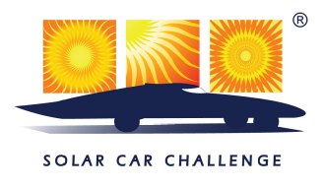

The Solar Car Challenge is an education program designed to help motivate students in Science, Engineering, and Alternative Energy. We teach high school students how to plan, design, engineer, build, race, and evaluate roadworthy solar cars. Students demonstrate that green technology can create a better world.

Science & Technology Magazine named the Solar Car Challenge as one of the top Science & Engineering programs in the country. NBC-Universal honored the Solar Car Challenge as a leader in their national Project Innovator Project.

The Challenge has 192 high school solar car projects in various stages of development in anticipation of an upcoming solar racing event. Teams are located in 36 states, Canada, Mexico, Costa Rica, Puerto Rico, and the Bahamas.

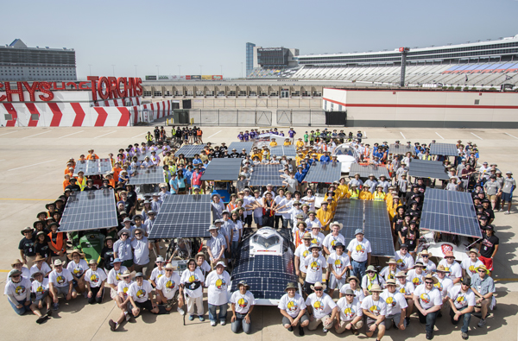
2018 Solar Teams on display at the Texas Motor Speedway, Fort Worth, Texas
High School teams begin preparation for their year-long project during education workshops scheduled in September 2018. Additional workshops, on-site visits, mentor opportunities, and summer camps help propel the projects to success. After qualifying for the 2019 Event, teams will get the opportunity to drive their solar cars at the world famous Texas Motor Speedway.

The 2019 Race will feature a new racing division: the Electric-Solar Powered Car. This Division features a two-passenger electric car powered by permanent solar charging stations. This brings “realism” to solar car racing! The SCC is hosted by Texas Instruments.

Media Day: Friday, July 12th, July 16th, 10:00 AM - 12:00 PM at the Texas Motor Speedway
Qualifying: Friday-Sunday, July 12-14, 2019 at the Texas Motor Speedway
Event Begins: Monday, July 15th at the Texas Motor Speedway, Fort Worth, Texas
Event Ends: Thursday, July 18,th
Contact person: Dr. Lehman Marks, Solar Car Challenge Foundation, 214.587.8489 LehmanM743@aol.com
http://www.solarcarchallenge.org

