WHERE-TO-BE / WHAT-TO-DO
2013 SOLAR CAR CHALLENGE

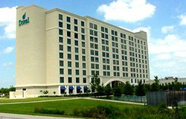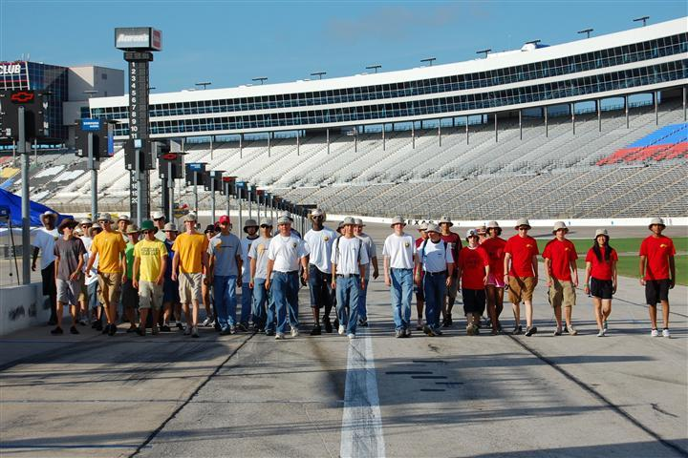

Saturday
July 20 .
10:30 AM Judges Training Workshop [10:30 AM – 3:00 PM]
Colorado Room, DFW Marriott
Lunch provided for Judges

4:00 PM Teams Check-In [4:00 – 7:00 PM]
Colorado Room, DFW Marriott
[All race participants must attend Team Check-In]

Teams need to bring the following:
- Release of Liability Form signed by families for SCC
- Release of Liability Form for the Texas Motor Speedway
- All drivers with their valid driver’s licenses [Driver Check-In]
- Teams will need to make arrangements if more than 14 people
(students, teachers, chaperones) are attending.
- Photo Album showing the team building their solar car

Teams will receive:
- Updated “Where-to-Be What-to-Do” Document
- 14 tee shirts
- 50 Official Race Booklets
- Traditional “baking soda” for environmental spills
- Rule Booklet
- Scrutineering Packet
- Identification Badges with lanyards
SCC Identification badges must be worn at all times.
- Draw for Starting Order for First Racing Day
- Racing Decals for solar car
- Experimental Vehicle Racing License
- Tickets for Awards Banquet

7:00 PM Pre-Race Orientation
Required for ALL Race Participants
Trinity Ballroom, DFW Marriott
Sunday
July 21
7:00 AM Teams Travel to CUP Garage Area entering South Gate of the Texas Motor Speedway. Staff will show teams their locations in garage and pit row.

Teams must not enter Speedway before the race staff arrives.
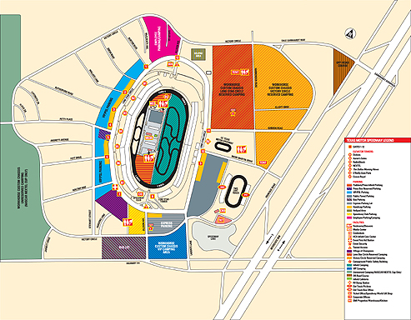
Adobe map attached with full details

8:00 AM Scrutineering Session No. 1 [8: 00 AM – 6:00 PM]
All cars must be ready to begin Scrutineering at 8:00 AM or will receive a penalty. [Rule 9.1] Hat Rule goes into effect.

Water Station Open – teams will be asked to periodically provide a
volunteer to help run the water station.

Guests – Guests seeking to observe teams during scrutineering need
to identify themselves with the guard at the South Gate. Guest hours: 9:00 AM – 3:00 PM. Designated parking areas for guests will be identified in the infield area. Only teams and support vehicles can park in the CUP garage enclosure. [These rules apply to guests on Sunday & Monday]

Scrutineering Stations 1-5 will be completed on Sunday
Scrutineering Stations 6 & 7 will be completed Monday morning. Teams should take care that their braking capability meets the requirements set out in the Rules. If a team’s brakes do not qualify by Monday morning, they will not be able to re-quality for the race until Tuesday evening in Snyder, Texas.

12:00 PM Solar Car Challenge will provide Dominos Pizza for race participants. [West End of Garage]

7:30 PM Opening Banquet
Trinity Ballroom, DFW Marriott Hotel at Champions Circle
Team Captains need to be prepared to introduce their team members, sponsors, and other guests Admission to all events requires SCC Identification badge.

Monday
July 22
7:00 AM Texas Motor Speedway Cup Garage Opens for Teams
The garage will be locked until 7:00 AM

8:00 AM Scrutineering Session No. 2 [8:00 AM – 5:00 PM]
Texas Motor Speedway CUP Garage Area

12:00 PM Spring Creek Bar-B-Q will provide a full lunch for teams
and staff at the West End of the CUP Garage.

5:00 PM Scrutineering Closes
Teams and staff are on their own for dinner
Tuesday
July 23

6:30 AM Race Staff travels to Northwest ISD for prepare for staging of the RACE START. Address: 2301 Texan Drive, Justin

7:30 AM Team should be at Northwest ISD location with solar cars ready
for running. Staff will direct teams to the proper staging area.

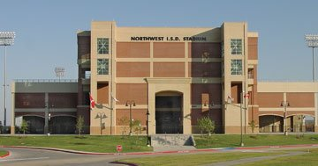

Coffee, Juice, and Doughnuts will be provided to race
participants and staff. (Pending)

8:00 AM Required Drivers’ Meeting at Solar Car Challenge Trailer
Last minute instructions for teams and drivers

8:30 AM Teams will be lined-up in the racing order determined during Team Check-In

8:50 AM OPENING CEREMONIES

The GREEN FLAG will be waved by the Northwest ISD Superintendant Dr. Karen Rue and Byron Nelson High School Principal Linda Parker

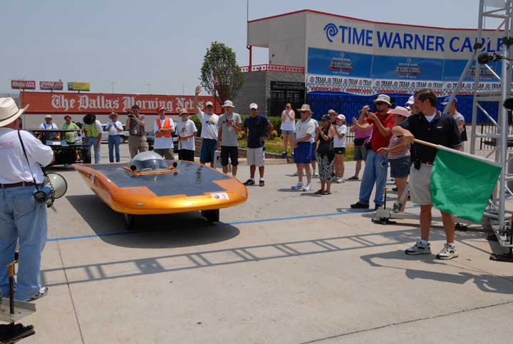

9:00 AM RACE START

10:00 AM Media Stop at Springtown Intermediate School,
Springtown, Texas. Principal Joe Brown [817.220.1219]

12:00 PM LUNCH STOP at Brazos Mall, Mineral Wells, Texas
Paul McGettes, Upham Oil Co [940.325.4491]

2:30 PM Media Stop at Stephens County Courthouse,
Breckenridge, Texas [254.559.2190]
County Judge Gary Fuller

7:00 PM Welcome Ceremonies in Snyder, Texas
Snyder Chamber of Commerce

7:30 PM Dinner provided by SCC on parking lot at
Western Texas College Coliseum.

9:00 PM IMPOUND: Western Texas College Coliseum.

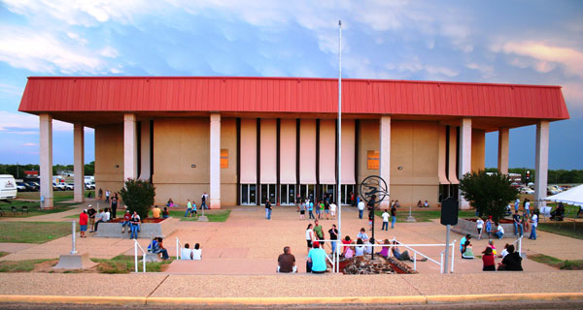
Western Texas College Coliseum

Event Hotel: Baymont Inn & Suites
1005 E. U.S. 180, Snyder, Texas 79549
Phone: 325.573.3700 Contact: Jamie
Wednesday
July 24
6:30 AM Impound Opens at Western Texas College Coliseum Parking Lot

8:00 AM Required Driver’s Meeting at SCC Trailer Presentation of Awards for First Race Day.

8:45 AM Solar Cars lined up at RACE START
The Starting Order will be based on the official number of miles earned during the preceding day of racing.

9:00 AM RACE START

GREEN FLAG: Officials from the Snyder Chamber of Commerce

10:00 AM MEDIA STOP
Borden County Courthouse

12:00 PM LUNCH STOP
Town of Seminole, Texas

3:00 PM MEDIA STOP
Hobbs Eagle Stadium Parking Lot
Hobbs, New Mexico

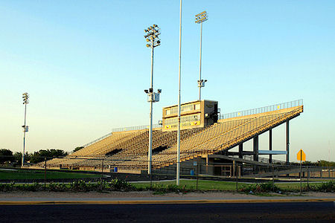
Hobbs Eagle Stadium

5:00 PM Arrive at Carlsbad Mall
Carlsbad, New Mexico

7:30 PM Dinner on Carlsbad Mall Parking Lot

9:00 PM IMPOUND: Carlsbad Mall Parking Lot

EVENT HOTEL: Holiday Inn Express
22101 W. Pierce, Carlsbad, New Mexico 88220
Phone: 575.234.1252 Contact: Jisa

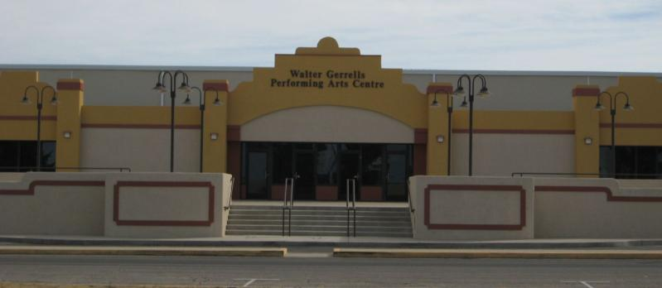
Walter Gerrells Performing Arts Center, Carlsbad, NM
Thursday
July 25
6:30 AM Impound Opens at Carlsbad Mall Parking Lot

7:00 AM Solar Cars are trailered to the Walter Gerrells Performing Arts Center
Parking Lot and readied for racing.

8:00 AM Required Driver’s Meeting at SCC Trailer at Walter Gerrells Performing Arts Center Parking Lot [at SCC trailer]
Presentation of Awards for Second Race Day.

8:45 AM Solar Cars lined up at RACE START
The Starting Order will be based on the official number of miles earned during the preceding day of racing.

9:00 AM RACE START

GREEN FLAG:

RACE DAY PREPARATIONS:
(1) Be sure that your team has adequate water for the race day. (2) There is no LUNCH STOP. Teams need to be prepared to bring
sandwiches with them for lunch.

4:00 PM Display Solar Cars at Franklin High School, El Paso, Texas

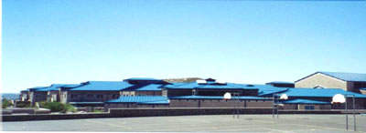

7:30 PM Dinner at the Display Area, Franklin High School

9:00 PM IMPOUND: Franklin High School Parking Lot

EVENT HOTEL: Holiday Inn Express
7935 Artcraft Road, El Paso, Texas 79912
Phone: 915.587.5885 Contact: Christina

Friday – Rest Day
July 26
8:00 AM Impound Opens at Franklin High School Parking Lot

9:00 AM DISPLAY OPENS
Teams need to have several team members with their solar cars in order to answer questions from the public.
.
10:00 AM PRESS CONFERENCE at the AZTEC PAVILLIOIN
Meet with El Paso Mayor and Council Members for Press Conference
Several teams will be asked to represent the SCC.

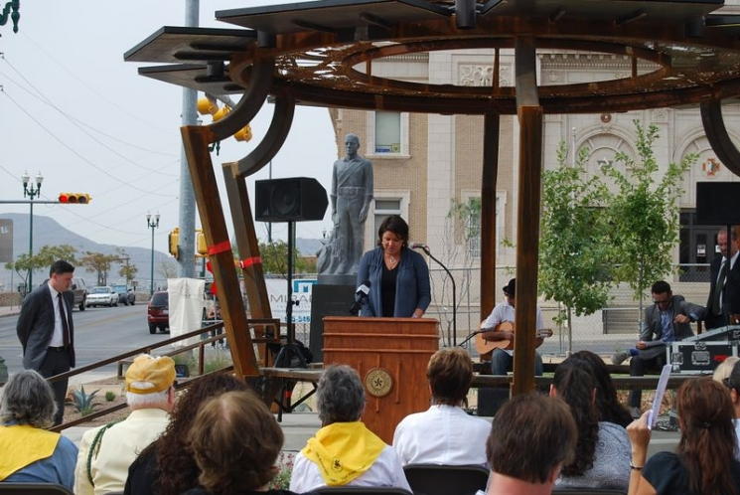

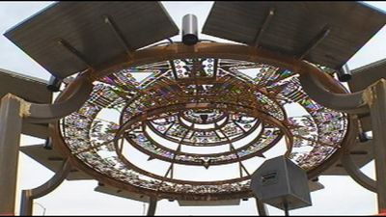

5:00 PM Display Ends
Dinner pending

5:30 PM Required Driver’s Meeting at SCC Trailer
This is in preparation for Saturday’s Early driving schedule
Presentation of Awards for Third Race Day.

9:00 PM IMPOUND: Franklin High School Parking Lot

Saturday
July 27
5:00 AM Impound Opens at Franklin High School Parking Lot

Teams will make arrangements to meet their judges at the hotel,
and then pick up solar car trailers at Franklin High School. It is a
162 mile drive from El Paso to Lordsburg, NM. Teams begin driving
from the point located outside Lordsburg at 9:00 AM.

12:00 PM LUNCH STOP
East Arizona College, Thatcher, Arizona

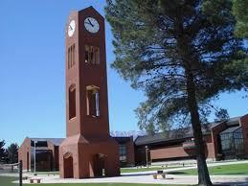

Solar cars are trailered through towns of Geronimo, Globe, and
Superior, Arizona.

5:00 PM Display at Heritage Park, Florence, AZ

7:30 PM Dinner on the Parking Lot, Heritage Park, Florence, AZ
Hosted by the Solar Car Challenge

9:00 PM IMPOUND: Parking Lot of Heritage Park

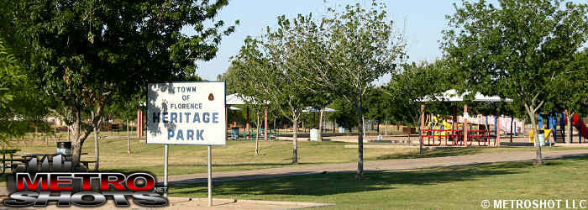
EVENT HOTEL: Holiday Inn Express
240 W. Highway 287, Florence, Arizona 85132
Phone: 520.868.9900 Contact: Jeanne

Sunday
July 28

6:30 AM Impound opens at the Heritage Park parking lot.

8:00 AM Required Driver’s Meeting at SCC Trailer
Presentation of Awards for Fourth Race Day.

8:45 AM Solar Cars lined up at RACE START
The Starting Order will be based on the official number of miles earned during the preceding day of racing.

GREEN FLAG:

9:00 AM RACE START
Teams will drive down Main Street in a Parade

10:30 AM REST STOP
Chandler High School Parking Lot
Teams will trailer their solar cars in the high school parking lot

12:00 PM LUNCH STOP
Pending in Phoenix

4:00 PM Display at Community Center, Town of Wickenburg, AZ

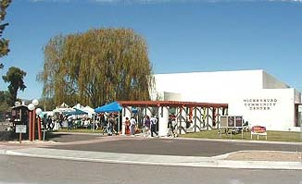
Community Center, Wickenburg, AZ

Teams are free to make their own dinner plans in this picturesque
Resort Community.

9:00 PM IMPOUND: Community Center Parking Lot

EVENT HOTEL: Best Western Rancho Grande [$72]
293 East Wickenburg Way, Wickenburg, Arizona 85390
Phone: 928.684.5445 Contact: Melody

Monday
July 29

6:30 AM Impound opens at the Community Center

6:30 – 7:30 Pancake breakfast at the Community Center prepared by the
Lioness Club of Wickenburg, AZ

7:30 AM Teams will drive West of Wickenburg on US 60. Be sure to have water in your vehicles! Race will start at Sunset Park 1.4 miles west of Vulture Mine Road. Note: There is an Alco Store on the left in case you need anything before the trip.

8:00 AM Required Driver’s Meeting at SCC Trailer located at Sunset Park
Presentation of Awards for Fifth Race Day.

8:45 AM Solar Cars lined up at RACE START
The Starting Order will be based on the official number of miles earned during the preceding day of racing.

GREEN FLAG:

9:00 AM RACE START

10:30 AM REST STOP
Town of Harcurver, AZ

12:00 PM LUNCH STOP
Parker, AZ

Caution: Teams need to be sure that they have sufficient water for a very dry afternoon.

5:00 PM Display in 29 Palms, California

7:30 PM Pizza Party for Teams
Location Pending

9:00 PM IMPOUND: Best Western Motel, 29 Palms, California

EVENT HOTEL: Best Western Garden Inn & Suites
71487 29 Palms Highway, Twenty-nine Palms, CA 92277
Phone: 760.367.9141 Contact: Casey

Tuesday
July 30

6:30 AM Impound opens at the Best Western Motel

8:00 AM Required Driver’s Meeting at SCC Trailer
Presentation of Awards for Sixth Race Day.

8:45 AM Solar Cars lined up at RACE START
The Starting Order will be based on the official number of miles earned during the preceding day of racing.

GREEN FLAG:

9:00 AM RACE START

12:00 PM LUNCH STOP
Teams will stop at Citrus College

1:00 PM RACE RESTARTED
It is very important that teams be on time. All teams must be ready
to drive out of the Citrus College parking lot at 1:00 PM.

2:00 PM MEDIA STOP

Teams will stop at the Los Angeles City Hall to receive a Certificate of Honor from the Los Angeles City Council

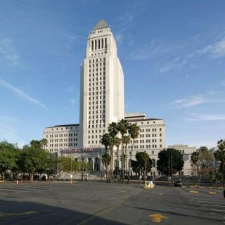

3:00 PM END OF RACE at Exposition Park
CALIFORNIA SCIENCE CENTER

Solar Cars will be on display at California Science Center
From Arrival until 6:00 PM.

4:00 PM Visit Space Shuttle
[pending]

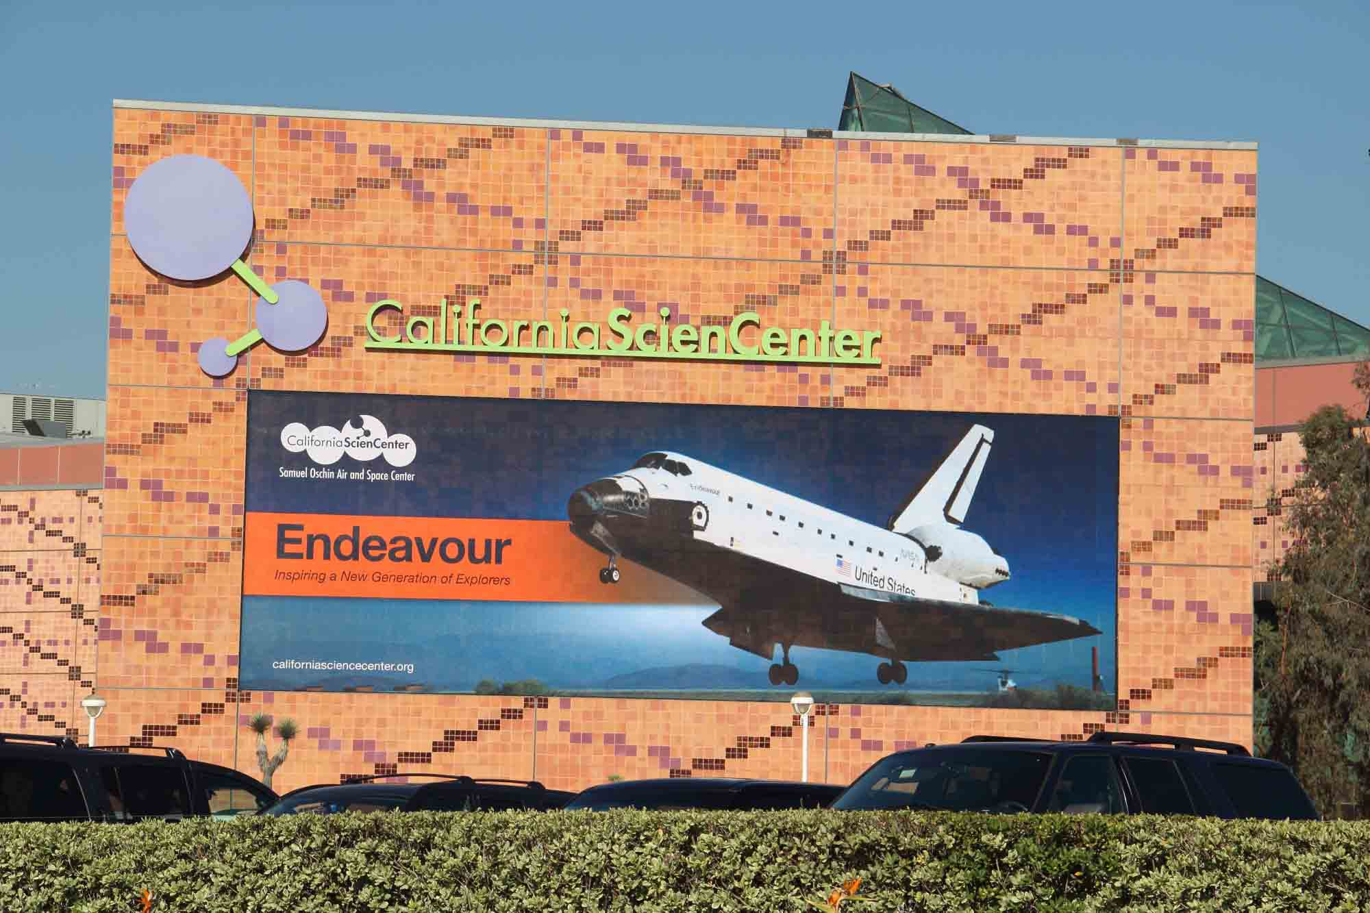

7:30 PM AWARDS BANQUET
Ballroom, Radisson Hotel Mid-Town

EVENT HOTEL: Radisson Midtown Hotel at USC
3540 South Figueroa, Los Angeles, California 90007
Contact: Gloria

Wednesday
July 31
5:00 AM Race Staff leaves from Los Angeles for Van Horn, Texas.

Thursday
August 1
7:00 AM Race Staff leaves Van Horn for Dallas

4:00 PM Staff returns to DFW Marriott

