NAVIGATING SCRUTINEERING
SOLAR CAR CHALLENGE
____________________________________________________

Pre-Scrutineering Activities
(1) Prepare a three-ring scrapbook that contains every document your team submitted
to the Solar Car Challenge. This includes the official registration documents, all “spec” documents, Emails, waiver requests, and other communications with the
Solar Car Challenge staff.
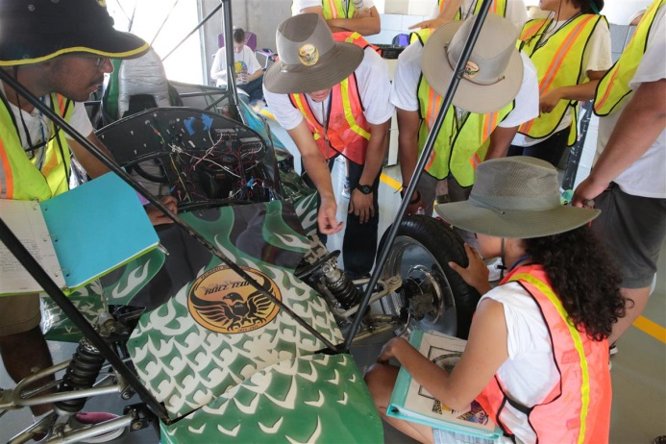

(2) Make sure that your document scrapbook has all of your needed computations:
(a) calculated efficiency of your solar array
(b) Kw/hr capacity of your battery pack
(c) Battery capacity at 20 hour discharge rate

(3) Make sure you have samples of key materials used in your solar car. A small piece
of the roll bar material, roll cage material, grade 8 bolts, batteries, wiring, etc. will expedite your visit to Scrutineering Station One and Two.

(4) Select two team members to be your representatives during Scrutineering. Have
these representatives use the Scrutineering Packet as a guide. Before you ever
leave your school, go through every question asked in the Scrutineering
Packet . . . . and know the answer to every question.

These same two team representatives should escort the solar car through all the
Scrutineering stations. Remember that teachers and consultants cannot be
present at Scrutineering stations. [100’ rule]

(5) The team should know how to safely move and lift the solar car. Specifically,
Scrutineering Station No. 3 requires the solar car to be tiled thirty degrees,
but do the representatives know where to safely place the jack without damaging
your solar car? Teams should practice this “tilt process.” Well prepared teams will bring their own jack and materials to enable a safe tilt of their solar car.
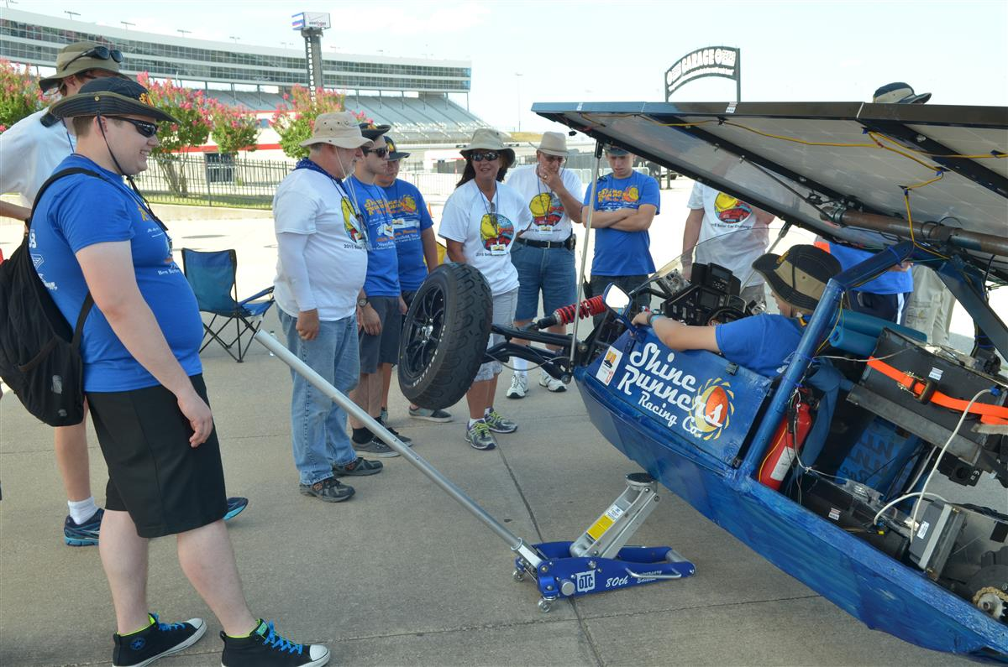

(6) The team should practice the “turning radius” test. Rule 5.11.1 requires solar cars
to be able to make a “U” turn within 15 meters.

(7) The Solar Car Challenge provides a registration document evaluation prior to a
team’s arrival at Scrutineering. Please make sure you have a copy of that
evaluation with you at the time of Scrutineering, and that you have addressed
the problems or issues spelled out in that pre-Scrutineering evaluation.

Scrutineering
(1) Scrutineering begins at 8:00 AM on the first day. Make sure your solar car is ready for inspection at 8:00 AM. Rule 7.1 requires a penalty to be assessed to a team not ready to begin Scrutineering at this time.

Some teams arrive at Scrutineering thinking they will have time to finish
vehicle construction and testing. This is not the case. Your solar car must be
finished when you arrive at Scrutineering. [Of course, work can be done at the
hotel parking lot before you arrive at Scrutineering.]

(2) Practice going through Scrutineering before you ever leave your school. Ask several
knowledgeable people to scrutineer your solar car before you leave home. This
helps you identify problems, as well as provides Scrutineering Representatives
practice answering questions. This builds confidence.

Guiding Principle: Teams that appear to be well prepared exude confidence, and
Demonstrate familiarity with the solar car. For instance, if a Scrutineering judge asks a student to show where their motor controller is connected to their motor, the students should not “look uninformed.”

(3) Be sure that your Team’s Scrutineering Representatives thoroughly know their
Electrical Schematic diagram. A Scrutineering Judge generally points to a point
on that diagram and asks the students to identify this location on the solar car.
Question: Can you track a wire from the switch to the object affected by that switch? For example, could you track a wire from a switch to the horn?

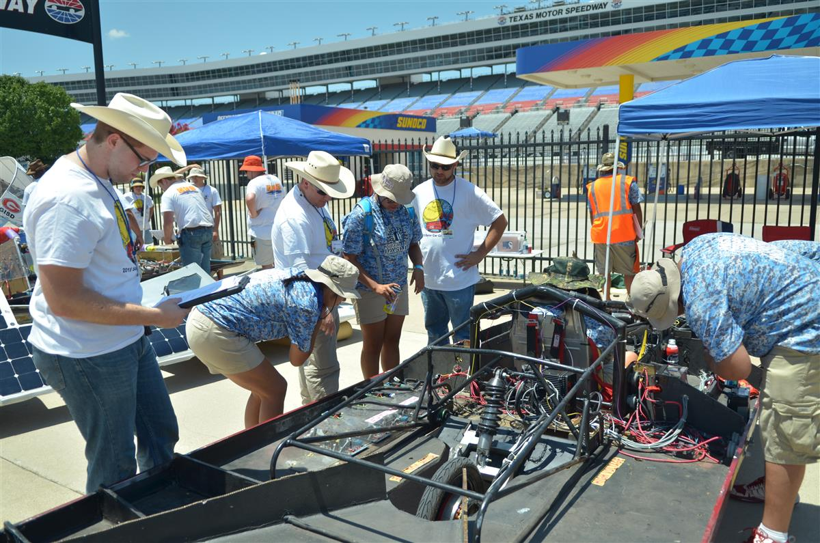

(4) Teams may be asked what size wire they are using for the following, and why!
(a) wiring size between the motor, motor controller, batteries
(b) wiring size between the solar array, power trackers, switches
(c) wiring size for the Supplemental System

(5) Teams will be asked to show that they used proper Grade 8 bolts in key areas of
the solar car. For example: the five-point driver harness.

(6) Teams will be asked to show that they have properly secured key nuts & bolts using
locking washers, locking pins, or Locktite. Team Representatives need to be
prepared to show this.

(7) Teams will be asked to show the location of their main fuse. Team representatives
should be able to explain that their choice of fuse does not to exceed 125%
of the expected peak current draw. [Rule 5.4.2]

(8) Be sure to be familiar with all sections of Rule 7 - Scrutineering

What to do when you arrive at Scrutineering
Bring your Scurtineering Booklet issued during Team Check-In

(1) Teams get access to their garage area at 7:00 AM. Quickly setup your garage area
between 7:00-8:00 AM, and be ready to start Scrutineering at 8:00 AM. A judge
will check to see if you are ready to have your vehicle scrutineered at 8:00 AM.

(2) Send your representatives to the Scrutineering Coordinators (center of the garage)
and let them know that you are ready to begin Scrutineering. You will be
directed to your first station. Teams do not necessarily go in numeric order, but are assigned based on station availability.

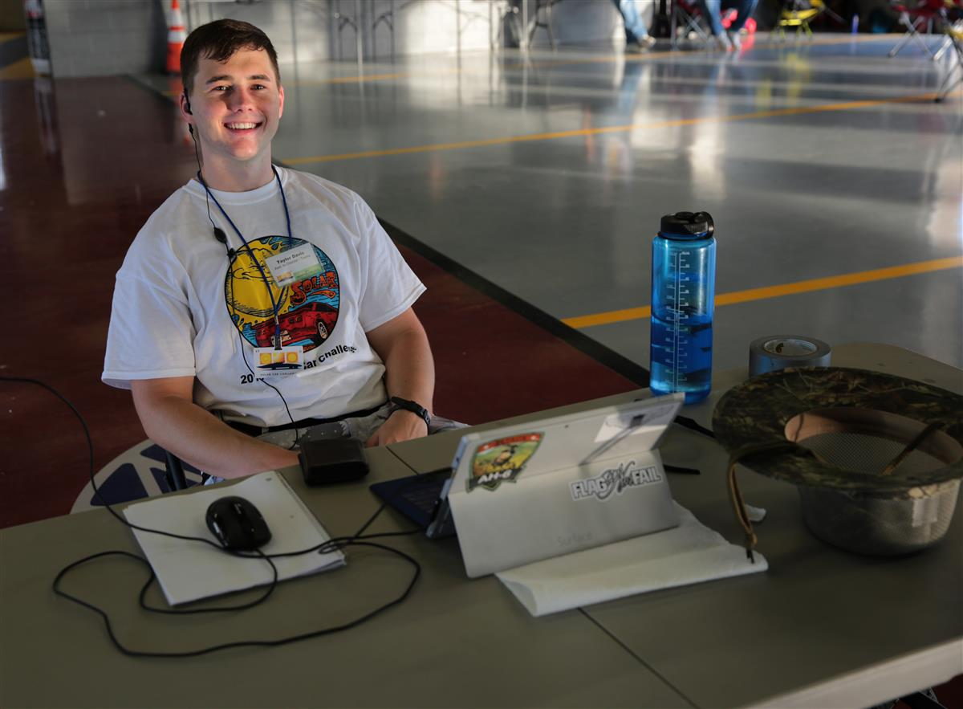

(3) After visiting a Scrutineering Station, you will know if you successfully completed
that station [Your Scrutineering Booklet will be checked off], or whether you have additional work to do [as noted in your Scrutineering Booklet].

(4) CRUCIAL: We recommend that you do not go back and immediately fix problems
identified at that first scrutineering station. Go back to the Scrutineering
Coordinator and get slotted for your next Scrutineering Station. Your goal
should be to visit at least three different Scrutineering Stations on your first day,
and then make repairs.

It is crucial that you visit ALL of the Scrutineering Stations as early as possible so that you have a good idea about the overall readiness of your solar car. Don’t get bogged down at a single station.

Remember, you have three days to pass Scrutineering. This means that you have your Scrutineering Booklet signed-off by the Lead Judge in each of the stations. Teams not passing Scrutineering at the end of this third day will not be able to race.

Specific suggestions
(1) Be sure to bring adequate back-up parts in the event that something breaks during
Scrutineering.

(2) Be sure your team has practiced braking! Does your solar car meet the
requirements set out in Rule 5.10 and 7.5?

Your car will be required to pass a “controlled” stop in Station 5, as well as an
Emergency/Panic stop in Station 6. Be careful that your solar car remains under
control during these quick stops, i.e., doesn’t “fishtail.”

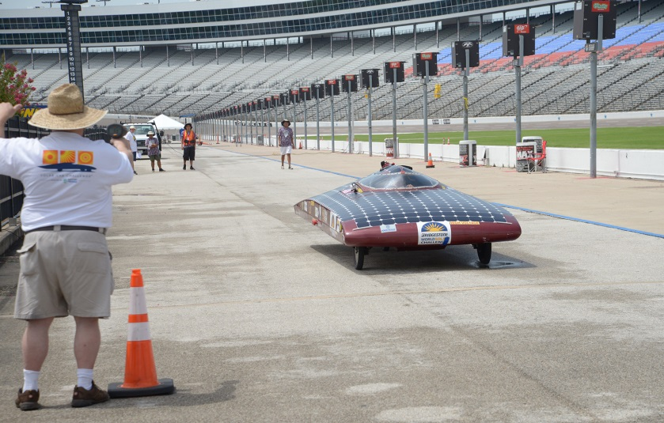

(3) Station four requires drivers to make an emergency egress from their solar car in
less than 15 seconds. The driver must have a plan to make this egress by
themselves, and must completely exit the solar car. Develop a plan to get out of your solar car without damaging your solar cells.

In the Electric Solar-Powered Division, both the driver and passenger are required to make this 15-second emergency egress.

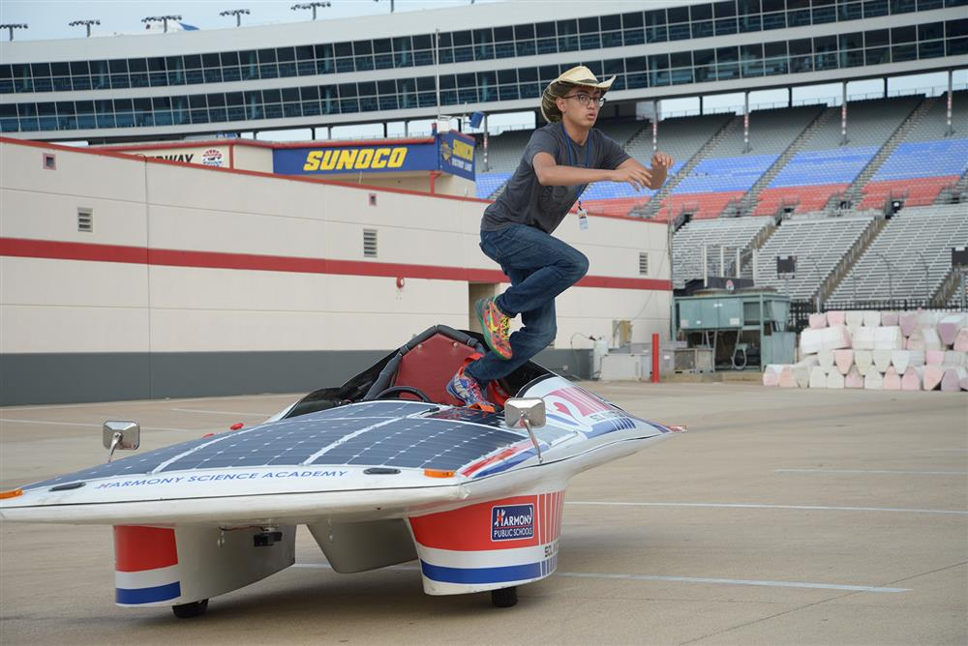

(4) Teachers, Consultants, and Parents must remain in the garage area during
Scrutineering. [Guideline: 100’ away from their team] Only students can represent their team with Scrutineering Judges.

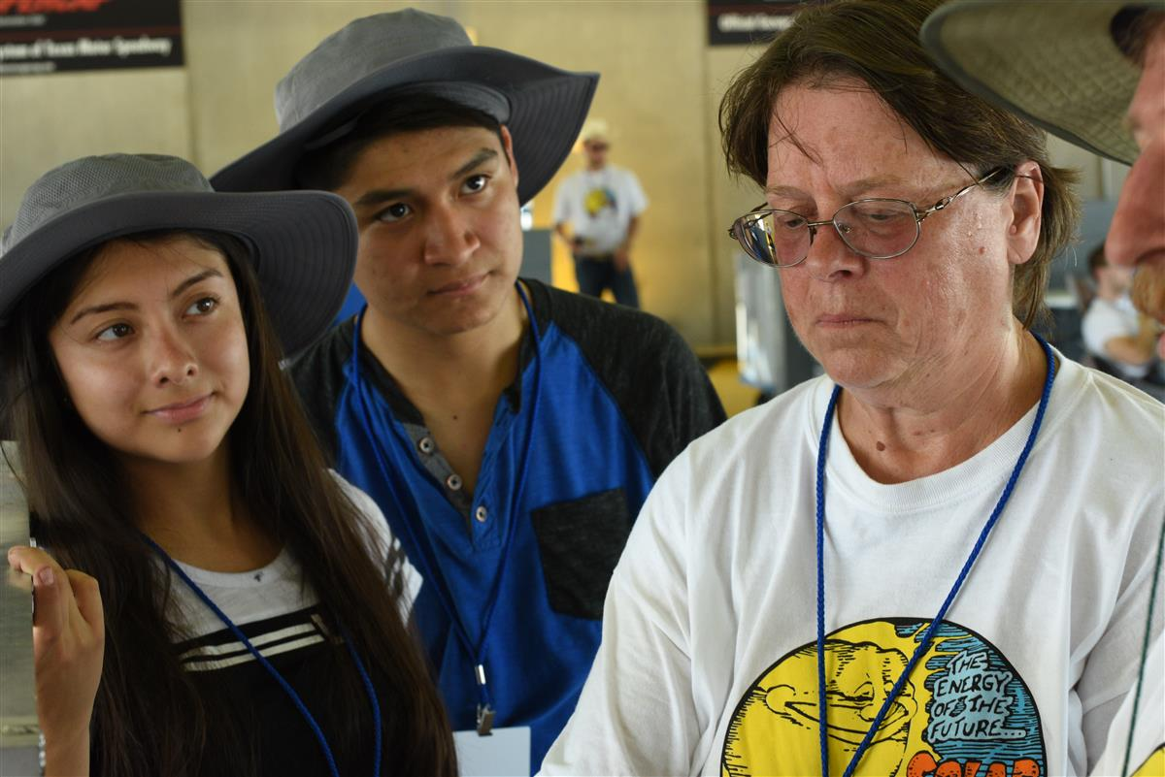

FINAL SUGGESTION
In the event of a problem that seems to be a real obstacle to your team’s passing Scrutineering, be sure to contact Dr. Marks, Event Director, no later than 12:00 PM on the last day of Scrutineering.

